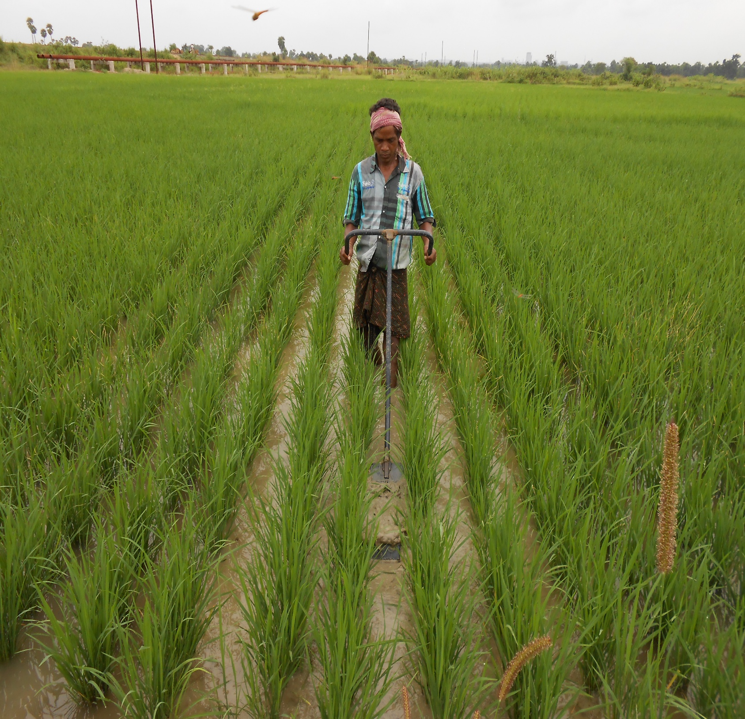
ANNUAL REPORT 2024-25

Annual Report
2024-2025

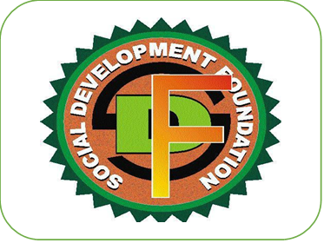
Social Development Foundation
At- Balhar Chhak, Po- Santhapada, Talcher,
Dist: Angul Pin-759104, Odisha
Phone- 9437904108, 8637287963, 7978222373
E-mail: -sdftalcher@gmail.com

Contents
Acronyms
About Social Development Foundation
Message from the Secretary
1} Livelihood Enhancement
A. Farm based Agriculture
1.A Micro Entrepreneurship development programme for WSHG on Millet based food Processing in Kankadahad
1. B Awareness programme on World Jackfruit Day 2024.
1.C. Awareness programme on DSR
1.D Awareness Programme on Maize Cultivation.
1.E Formation of PRODUCER GROUP on Maize.
1.F Seed Treatment Campaign.
1.E Foundation’s Participation in District / Block Level Farm Mechanization Fair.
2. Education
3.1 Awareness programme on Sexual Harassment.
3. HEALTH
3.1 Awareness programme on Menstrual Hygiene Day 2024.
3.2 Awareness programme on Eco-friendly Sanitary Pad.
4.WOMEN EMPOWERMENT
2.1 International Womens DAY -2025.
5.Environment
5.1 Awareness programme on World Environment Day.
6.CSR
5.A Micro Entrepreneurship development programme for WSHG on Millet based food Processing in-NTPC / TTPS, TALCHER.
5.B Micro Entrepreneurship development programme for WSHG on Millet based food Processing.
in-NTPC / KANIHA.
7} Success Story
7.1 A success story of micro-entrepreneur from struggle to success
8} Media Highlight

Acronyms
Ac: Acre
ATMA: Agriculture Technology Management Agency
ANM: Auxiliary Nurse Midwives
AWW: Anganwadi Worker
BDO: Block Development Officer
BKRY: Biju Kanya Ratna Yojana
BPL: Below Poverty Line
CBO: Community Based Organizations
CSR: Corporate Social Responsibility
FRA: Forest Right Acts
GOI: Government of India
GOO: Government of Odisha
HIV: Human Immune deficiency Virus
IAY: Indira Awas Yojana
IAS: Indian Administrative Service
IMR: Infant Mortality Rate
KBK: Koraput, Kalahandi and Balangir
KVK: Krishi Vigyan Kendra
MGNREGS: Mahatma Gandhi National Rural Employment Guarantee Scheme
MMR: Maternal Mortality Ratio
NFSM: National Food Security Mission
NGO: Non-Government Organisation
NABARD: National Bank for Agriculture and Rural Development
PDS: Public Distribution System
PHC: Primary Health Centre
PNC: Post Natal Care
PRI: Panchayati Raj Institution
PWD: Public Works Department
QPR: Quarterly Progress Report
RCH: Reproductive Child Health Care
RKVY: Rastriya Krishi Vikas Yojana
RTI: Right to Information
SHG: Self Help Group
A GLIMPSE INTO SOCIAL DEVELOPMENT FOUNDATION
Social Development Foundation, literally meaning “Upliftment of grassroot people” is a non-government Organisation taking all effort for the development of grassroot people & brings about positive changes in the communities in Odisha. Social Development Foundation has been actively involved in development activities since 2010/2011. Along with conservation and resource generation. The Organisation is working towards enhancing the access of people to land, water and forests with increasing the productivity of these resources in environmentally sustainable and socially equitable ways. With this the Organisation is also promoting the conservation of traditional knowledge along with values of marginalized people. Work of Social Development Foundation can be classified in Ensuring Education for all, Maternal & child Health, Promotion and conservation of Agriculture along with climate. Social Development Foundation maintains its head office at-Ballahar Chhak, 3kms from Talcher and 20kms from District HQ. Angul, Odisha, Social Development Foundation has been able to reach the 118537+ Population of 121 Villages of 69 Gram Panchayats of 30 Blocks of 7 Districts.
Vision-To engage, educate and empower vulnerable communities for significant socio-economic transformation.
Mission: Social Development Foundation’s initiatives are focused on Rural Development, Environment, Social Change, Gender Equality, Sustainable Agriculture & Livelihood, Health, Climate Change and in particular to build up an institutional base for addressing the problems of Tribal, Dalit, Rural Poor and women and children at grassroot level. And in furtherance to the above: -

➢ To take up programmes of awareness and consciousness on raising issues about the socio-economic, environmental and political problems of tribal Dalit and rural poor, aiming at reduction of disparity at all levels.
➢ To take up programmes on education for women and children, including legal education.
➢ To Provide necessary assistance and service for the vocational training/ income generation projects for artisans, youth, women, handicapped, socially and economically backward people .
➢ To become self-supporting in areas of agriculture, animal husbandry and processing on no-profit and no loss basis.
➢ To establish a training base for the grass-root functionaries drawn from the target group as well as the young educated professional. The training would cover Health, Environment, Livelihood, Skill improvements and income generating activities.
➢ To promote appropriate technology and renewable and non-conventional sources of energy.
➢ To develop areas of mutual co-operation and understanding among different voluntary organizations, NGO Networks, Research and Resource Organization and other Govt. and Non-Govt. agencies working for similar cause in India or elsewhere.
A note from the Founder cum Secretary
Dear Friends,
Dear Friends,
We are thrilled to present Social Development Foundation’s Annual Report for 2024-2025—a year marked by remarkable achievements and significant milestones. This year, as Social Development Foundation completes 15 years, its contribution to the field of rural development continues to gain recognition statewide.
We were happy that we could collaborate with the Government in the promotion of Direct Seeded Rice (DSR) drive and ensure 100% farmers of the Chhendipada and Kaniha blocks of angul districts are fully benefited under the project. For last fourteen years, foundation has been working in the Angul and nearby district continuously. An energetic team of dedicated young mass engages throughout the year 24x7 for the humanitarian services support, guide and convergence with GoI &GoO.
As you go through this report, you can find inspiring stories of transformation and the positive changes brought to the lives of people in odisha Slums by the SDF a team through its community-based thematic interventions on SRI and SMI for higher yield of paddy & millets, Promotion of food processing, Climate smart agriculture through Jackfruit, Organic Farming for a hazardous free agriculture, Waste Management, Natural Resource Management and its conservation, women empowerment women rights and child rights, financial inclusion, and infrastructure development. Thank you for your generous support that has made our work possible and for spreading the message of SDF far and wide."Annual Report 2024-2025" will encourage you to continue or join our efforts to support and improve rural society's marginalized sections.
Budhadev Das
FounderDirector
Social Development Foundation

- Livelihood Enhancement
It was never an easy task for the women, especially who are unemployed and others with a very low income.
A. A Micro Entrepreneurship development programme for WSHG on Millet based food Processing in Kankadahad
1.A Micro Entrepreneurship development programme for WSHG on Millet based food Processing in Kankadahad on 25th July 2024, the SHGs members attended a training workshops for 15 days organized by the Social Development Foundation under the MEDP project of NABARD. At this workshop, they learnt about the benefits of Food processing and preparing self storage products such as Nimki, mixture, sev, bundi, biscuit & cakes. The workshops proved revolutionary for the SHGs as the process shown was very easy and they just need to know some techniques. The trainings have been extremely successful as they could learn how food processing gives a very good start up and profit.

1.B Awareness programme on World Jackfruit Day 2024.
Jackfruit Day is observed on July 4th each year to mark the nutritious benefit of Jackfruit. Awareness programme on Jackfruit day was observed by Social Development Foundation, talcher at Kankadahad in collaboration with Kankadahad G.P on dt-04/07/24. Near about 50 participants participated in the programme. Various discussion were made on the topic such as jackfruit cultivation, grafting ,value addition, in cubation center and enterpreneurship etc.The programme was attended by concern Sarapanch, AWW, ASHA, FLW and GRS etc. 50 Participants from different groups participated. On this occassion Jackfruit Chips was distributed among members.Along with others Mrs. Alakananda Sethi AHO,Kanakadahad also attended the programme and was very pleased with the approach on Jackfruit. She also tasted jackfruit chips,also carried a small amount for her office staff.
1.C. Awareness programme on DSR
Training programs on mechanized Direct Seeded Rice (DSR) in Odisha are being conducted to promote the adoption of this technology among farmers. These programs aim to equip farmers with the knowledge and skills to utilize mechanized DSR effectively, leading to increased yields and profitability. “Precision direct seeded rice based diversified systems for transforming labour requirement, yields and profitability of smallholder farmers in Odisha” in short “DSR-Odisha project” funded by the Government of Odisha in collaboration with Department of Agriculture & Farmers’ Empowerment (DAFE) the sub-scheme Promotion of Improved Package of Practices (PIPP) under the State Sector scheme” Crop Production Management” 2024. The project aims to increase productivity and ensure socio-economic and environmental sustainability while improving smallholders’ profitability in rice-based systems by catalyzing wide-scale adoption of mechanized and precision broadcast DSR during Kharif. With a convergent approach with District Agriculture officer (CDAO) and partnership with public and private sectors, improved technologies and better bet agronomy are taken to farmers through a series of on-field demonstrations. A collaboration between the Department and the Government of Odisha, with 320 Women’s Self-Help Group, has also been established. a series of demonstrations, sequencing with Kharif rice (wet season), feasible Rabi crops (dry season) like green gram, black gram, groundnut, maize, and others have been demonstrated at various locations of the project in Chhendipada and Kaniha of Angul District of Odisha.

1.D Awareness Programme on Maize Cultivation.
Maize, a cereal crop of immense significance, occupies the second rank in importance in Odisha's agricultural landscape, following closely behind paddy cultivation. An awareness program on maize cultivation in Odisha is crucial for promoting better farming practices and increasing yields, particularly in light of the state's efforts to diversify crops and improve farmer incomes. Social Development Foundation successfully organized a Field Day training of stakeholders activity on “Improved Hybrid and Traditional Maize Cultivation in Nagira , Baradiha and Bandhabhuin G.P of Pallahara block of Angul,Odisha” from 4-5 June 2023. SDF maize technical lead in Odisha, Manoranjan Swain, Anita Patra and conducted the trainings. Seventy-three participants, including 15 male trainees, attended the programme. The participants were mainly from SDF project staff, including some progressive farmers who were members of Farmer Producer Groups (FPGs). The objective of the training was to create awareness and impart knowledge about mechanization, improved hybrid maize cultivation, balanced nutrient management, integrated weed and FAW management while emphasizing the positive impact maize cultivation is bringing in the livelihoods of the farmers, both men and women in the region.
1.E Formation of PRODUCER GROUP on Maize.
Building strong community where women are treated equal with men. A developed community where women take active participation for family and society A producers group (PG) shall consist of 10–20 primary women producers varying the membership from activity to activity. The idea of forming producer group is to create a platform for poor producers that will enable them reliable and affordable access to livelihood support service and market linkage at the village level.In this context ,the foundation has a mandate to work with women farmer under “My Vegetable My Land”Land”, so the primary member of the PG will be women primary producer from a rural household.
1.F Seed Treatment Campaign: -
By simple seed treatments farmers can reduce half of the diseases in crops. This can be done both organically and by using pesticides. With the help of the Maa Grameswari PG, Pallahara Angul the foundation organized several seed treatment programmes in Pallahara Block during Kharif. A total of 5 villages were covered during Kharif A total of 150 farmers participated in the programme and get their seeds treated. The programme in the name of “Bihan Bishodhan Abhijan” started from 07 June and ended 7th July 2024 during Kharif The overall objective is to create awareness among the farmers regarding the importance of seed treatment, which are as follows
- Maximizing the germination.
- Maximization of production.
- Conservation of ecology.
- Creating best practices of farming.
- Adoption of economical method.
- Productivity of crops.
1.F Foundation’s Participation in District / Block Level Farm Mechanization Fair.
Over a decade we have been participating state level trade fair at our district and other districts also Farm Level Mechanization Fair.
2. Education 

An awareness program on sexual harassment aims to educate individuals about what constitutes sexual harassment, how to recognize it, and how to prevent it, while also providing information on reporting mechanisms and support systems. These programs are crucial for fostering a safe and respectful environment, particularly in workplaces and educational institutions.
2.1 Awareness programme on Sexual Harassment.

The Social Development Foundation ,Talcher had organized “Awareness Programme on “Sexual Harassment at Workplace (Prevention, Prohibition and Redressal) Act – 2013” at on 2nd September 2024 for Students and Staffs of DAV TT High School ,NTPC /TTPS,TALCHER as per the direction of Ministry of Women and Child Development, New Delhi . 150 (100 Girls and 50 Boys) of staffs including DAV Committee members were actively participated in this awareness programme. Mrs.Mamatarani Bisimajhi Programme officer of social development foundation has served as Resource Person for this awareness Programme. The resource person briefly explained about the gender inequality with gender related concepts like Sex Vs Gender, Gender Discrimination, and Traditional and Cultural practices and inequality etc with examples. She also described about the Ministry of Women and Child Development,New Delhi and the recent schemes and activities related to SHWWP (PPR) A- 2013. Importance of this programme and myths and facts about Sexual Harassment at Workplace also explained examples including do’s and don’ts at work for both gender. In the discussion session the participants were asked their doubts. The brief lecture was given about Internal Complains Committee (ICC), District Complaints Committee (DCC) to the target group. The feedback from participants about this awareness programme was informative, rendered valuable legal information to make us aware about the sexual harassments undergone by women at various workplaces and the importance of update our knowledge in right way .
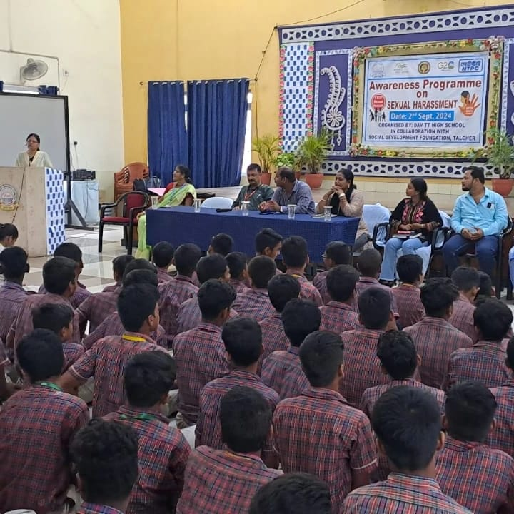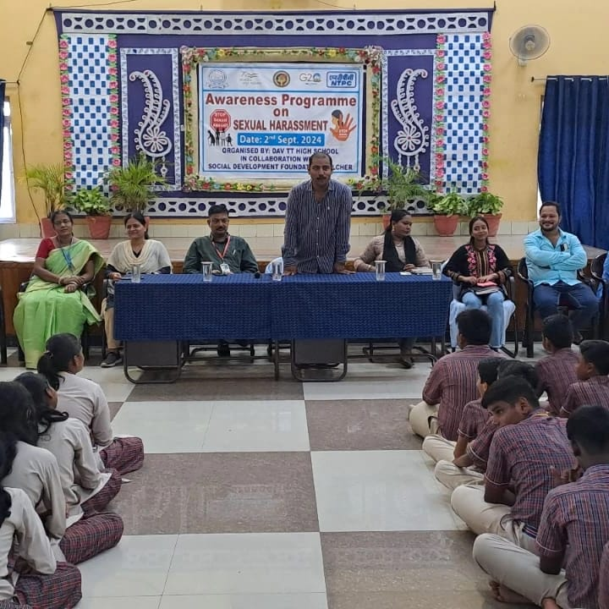

3. HEALTH 

Every year Menstrual Hygiene Day is observed on May 28th with an aim to break taboos surrounding menstruation and raise awareness about the importance of menstrual health and hygiene. Social Development Foundation celebrated the day to promote access to safe and hygienic menstrual products.

3.1 Awareness programme on Menstrual Hygiene Day 2024.
Every year, Social Development Foundation, talcher observed World Menstrual Hygiene Day on 28th May, coinciding with the International Day of Action for Women’s Health, to promote good menstrual health and hygiene for everyone around the world. To mark the occasion, SDF Organized an awareness camp on Menstrual Care in association with SPANDAN. The programme started with a Welcome Address by the Bibhu Sathapathy Director of Spandan NGO,Kandasar Angul .Mrs Mamatarani Bisimajhi drew attention to the importance of menstrual care and the social issues faced by women during menstruation. Banalata Murmu ASHA ,Ela Pattnayak and Durgi Samal gave a presentation on ‘Fundamental Knowledge of Menstrual Cycle and Menstrual Care’. Ms. Padmalaya Bisimajhi delivered a speech on the negative social norms around menstrual health and urged the girls to manage their menstruation safely, hygienically, with confidence and without shame. The following key objectives are as follows:-

Key Objectives are :
- Educate
- Break Taboos
- Promote Hygiene Practices
- Increase Awareness

3.2 Awareness programme on Eco-friendly Sanitary Pad.

An awareness program focused on eco-friendly sanitary pads aims to educate women and girls about the benefits of using sustainable menstrual hygiene products, promoting both environmental and personal health. These programs often involve workshops, demonstrations, and educational materials to address concerns about menstrual hygiene management, reduce stigma, and encourage the adoption of eco-friendly alternatives like reusable cloth pads or biodegradable disposable pads.
In this context, the foundation has organised a awareness program on the usage of biodegradable sanitary pad in collaboration with Mata Amritanandamayi Trust, Kerala under Saukhyam 13.02.2025. The resource person and programme officer of Social Development Foundation spoke about the importance of usage of bio-degradable sanitary pad. The female staffs of the institution witnessed this event.

4.WOMEN EMPOWERMENT

2.1 International Womens DAY -2025.
Social Development Foundation & Mamata Udyog, Talcher in collaboration with NABARD observed International Women’s Day 2025 held in Atma conference Hall of Angul District. The events reflected the multiple dimensions of women's empowerment like their leadership in Farm , Off-Farm and Non-Farm etc. The line department officials, PRI members, FPOs and WSHGs discussed the success stories and experiences in women empowerment.
The event glittered with demonstration of Branding & packaging millet and jackfruit based food products , felicitation of successful women farmers and entrepreneurs. Mrs.Jogeswari Behera Dy-SP, Mrs. Sanjukta Bebartta Educationist, Sj.Choudhury Deepak Mishra LDM Angul and Sj. Ashutosh Ray DDM NABARD were guest of honor for the programme.
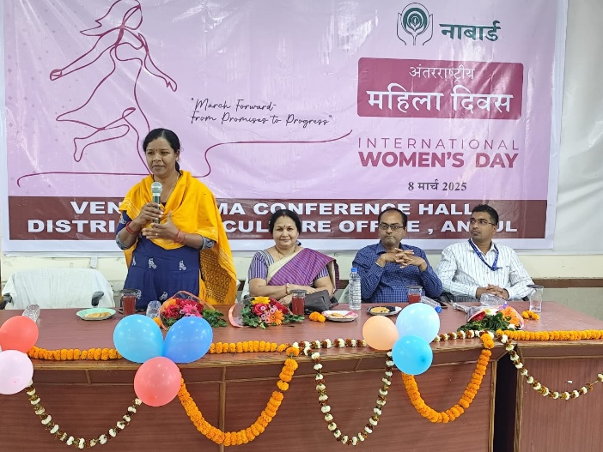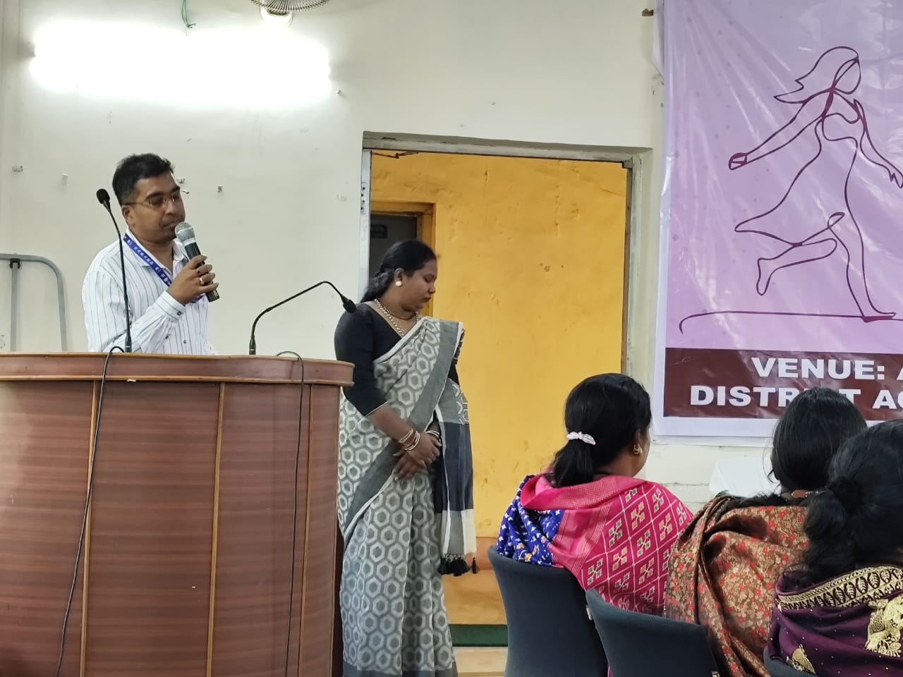
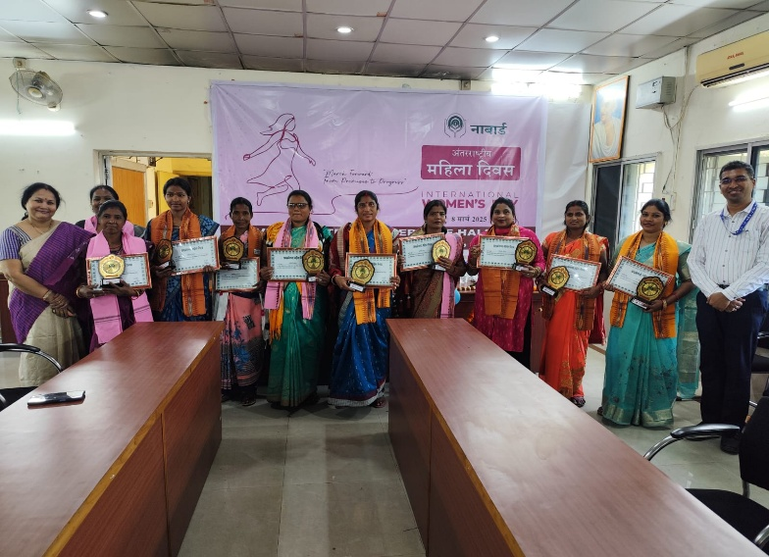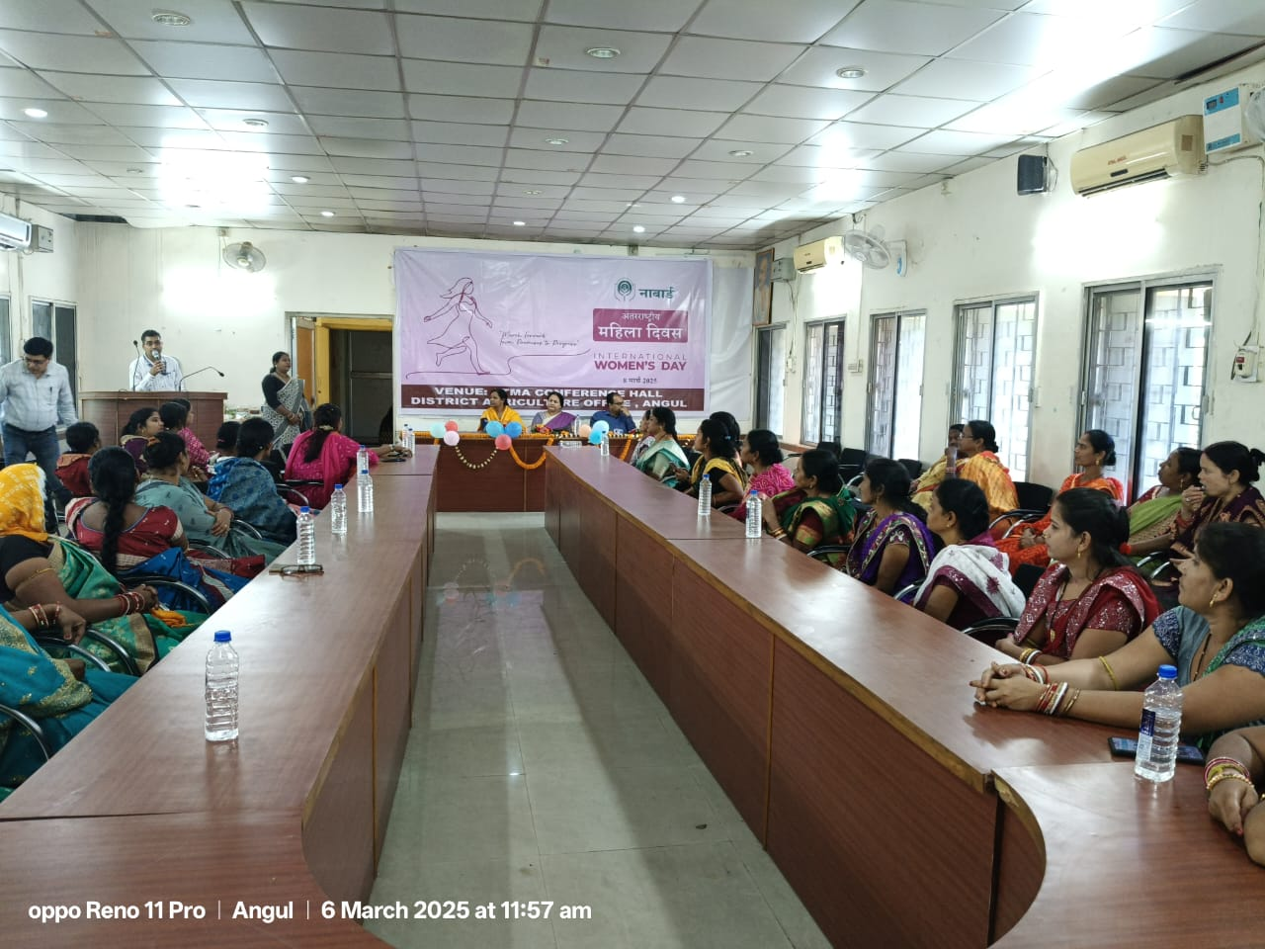

5.Environment

5.1 Awareness programme on World Environment Day.

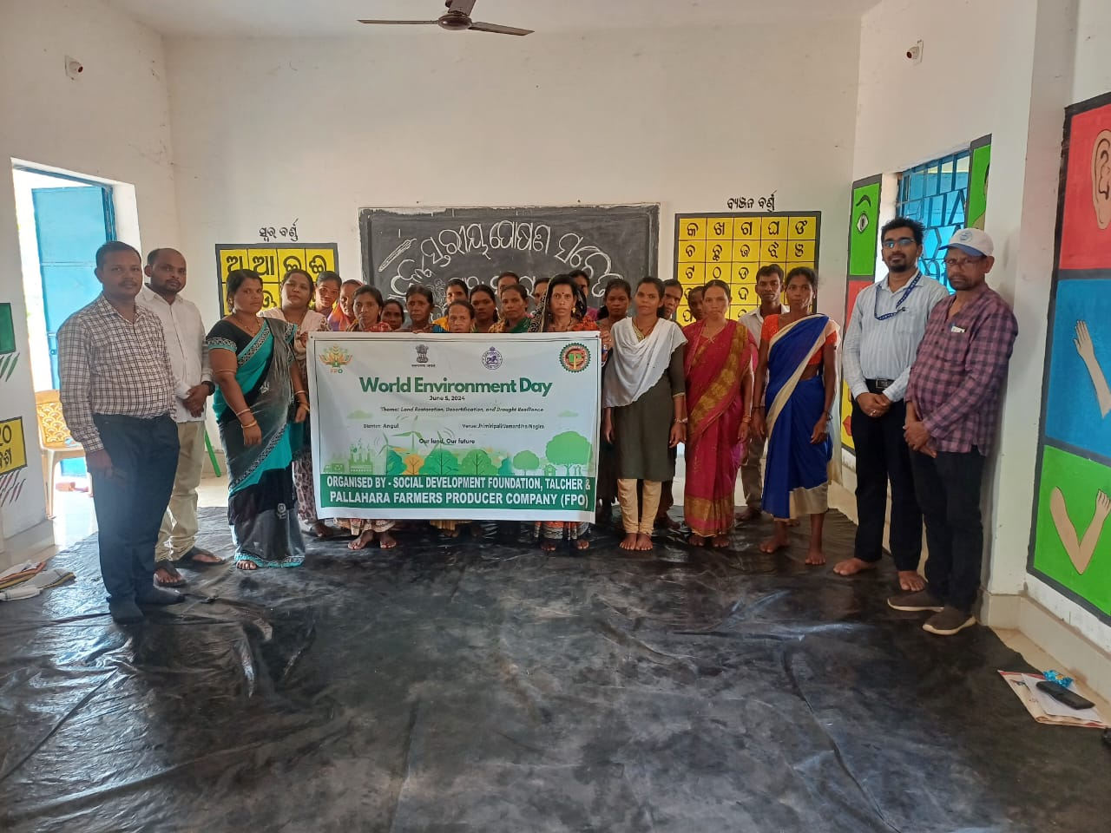
World Environment Day was organized at Nagira and Jhimiripalli panchayat of Pallahar block in collaboration with Pallahara FPO on 05.06.2024. The programme started with welcoming of the Guest speaker, District Development Manager (DDM)NABARD on to the Dias. It was followed by brief about Environment and reason behind organizing World Environment Day. Signification of apart from theme of World Environment Day 2024 (“Land Restoration, Desertification and Drought Resilience” under the slogan “Our land - Our future) it also covered aspects on intervention in Environmental Pollution and ways to overcome these problems at individual level as well as community level.The DDM NABARD , Sj.Ashutoth Roy addressed the gathering by his adorable speech on plastic pollution and its hazardous. The address also highlighted the global warming, climate changing and negative effects on Agriculture and allied sectors apart from the need of climate resilient Agricultural practices. It also focused on the need for environmental literacy, Sustainable Development, Sustainable Agriculture and Sustainable Livelihoods. This programme was attended by staff s of social development foundation and Pallahara fpo , apart from 50 of Wshg members of each g.p were participated. The programme ended with vote of thanks presented by the programme Officer of foundation , Mrs.Mamatarani Bisimajhi.

6. CORPORATE SOCIAL RESPONSIBILITY (CSR)

5.A Micro Entrepreneurship development programme for WSHG on Millet based food Processing in-NTPC / TTPS, TALCHER.

The Millet Food Processing and preservation Training Programme for WSHG Members House wifes and students was held at Bantol Gram panchayat training Hall around 10:30 A.M under the chairmanship of Chief Guest Mrs. Vibha Agarawal President – Sagarika Ladies club, Sarmistha Sahoo Secretary Sagarika Ladies Club,, other Ladies club members such as Ahalya Shinde, Deepti Awasthi, Parul Garg, and Jayantilata Pradhan Sarpanch Bantol. Mrs Jayantilata Pradhan enlightened the participants actively participated and shared information on Skill based activities on Millet based Food Processing to wshg members. Concerned CSR team Ms Shalini sheku and Ms Pallabi dey NTPC TTPS and Ms Sandipta Bir Burma Young Professional social Development foundation also participated and shared “Why Self-Help Group is important” in present context. Mr. Samit kumar Dev, DGM NTPC and Mr. Shakil Ahmed DGM NTPC /TTPS Talcher thermal also joined the training programme and encouraged the WSHG members and shared his ideas and experiences. PRI representatives and Media were present in the said programme. The event was marked with lighting of lamp by Chief Guest & other guest of honour in the dais. At the outset Mr. Budhadev Das, Secretary, Social Development Foundation welcomed all the members of SHG of concern Village, Media & guests in the programme. Mrs Mamatarani Bisimajhi, Ms subhashree Sahoo, Mrs. Kadambini Dehury and Mrs. Tunirani Dehury was selected as trainer and trained the members in the said training.

5.B Micro Entrepreneurship development programme for WSHG on Millet based food Processing. in-NTPC / KANIHA.

The Millet Food Processing and preservation Training Programme for WSHG / Producer Group Members was held at Multi Skill Centre (TTS) around 11:30 A.M under the chairmanship of Chief Guest Mr. A.K Sehgal, ED of NTPC Talcher Kaniha ,Mr.Navneet Kumar HoHr, Mrs.Sujata Rath HR-AGM, Jitendra Kumar Sr.Manager-HR. Mr Ashok Kumar Sehgal enlightened the participants actively participated and shared information on Skill based activities on Millet based Food Processing to wshg members. Concerned CSR team Mr.Bhisma Naik of NTPC Kaniha and Mr.Mahadev Das social Development foundation also participated and shared “Why Food processing is important” in present context. Mr. Jitendra Kumar Sr. Manager-HR NTPC Talcher Kaniha and Mr. Sagnik NTPC Talcher Kaniha also joined the training programme and encouraged the WSHG members and shared his ideas and experiences. PRI representatives and Media were present in the said programme. The event was marked with lighting of lamp by Chief Guest & other guest of honour in the dais. At the outset Mr. Budhadev Das, Secretary, Social Development Foundation welcomed all the members of SHG of concern Village, Media & guests in the programme. Mrs Mamatarani Bisimajhi, Ms.Sandipta Birburma, Mrs. Pravati Sahoo and Mrs. Lajita Mohapatara was selected as trainer and trained the members in the said training.

7.Success Story

7.1 A success story of micro-entrepreneur from struggle to success.

Being a good mother and home maker is the goal of every housewife, but this is not only the motto rather she balances work and family by setting up an example for destituted, poor, neglected tribal women and teaches them to live with pride and equality. She not only trained herself rather also gave training to others on behalf of foundation. With the help of Punjab National Bank, Talcher Thermal and Social Development foundation she opened a rural mart in the name of Mamata Udyog at Ballahar Chhak, Talcher and even employed 3 ladies. This mart has organic rice, manually pounded rice, pulses collected from different types of farmers cold press oil, wild honey, tamarind, hill broom, oilseed crops, Millets (such as Finger Millet, Great Millet, Foxtail Millet, Ditch Millet, Pearl Millet, Barnyard Millet & Proso Millet). Various ready-made food items from millet and jackfruit such as Mixture, Cake, Rose Cake, Arisha Pitha, Pickles, Papad, Chips etc. are being supplied at affordable prices. Udyog also focuses on selling terracotta items, bamboo Crafts, jhute bags, palm leaf carvings collected from small and renowned farmers and skilled artisans through sold through her platform. To enhance the productivity & increase the participation of women in business she ventured into a processing unit where varieties of flour and spices are processed at 2 different blocks and has employed 5 ladies. Besides this she also provide catering services to government and private institutes and corporate bodies. Students from National Institute of Technology Rourkela, SOA University Bhubaneswar and Gandhi Institute of Technology, Gu increase the participation of women nupur also visit her rural mart for their further learning on marketing, branding, packaging and business strategies etc. Training programme has been prepared and carried out primarily by NABARD and in coordination with the local corporates NTPC, MCL and providing training programs on food processing to women of the SHGs in the districts and various rural areas of the KBK district. She made sure to provide income round the year to the WSHGs by providing a platform at her store. With the help of family, local inhabitants, government officials and experts introduced her as an entrepreneur in the local area. As for her this is just the beginning,there’s more to achieve.
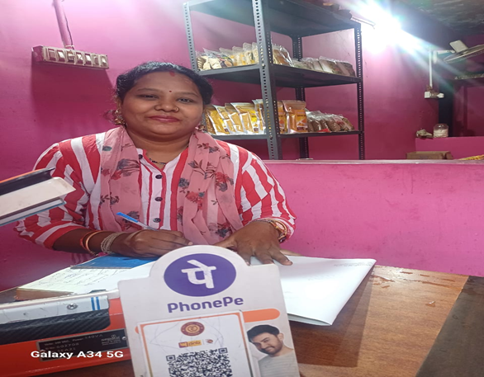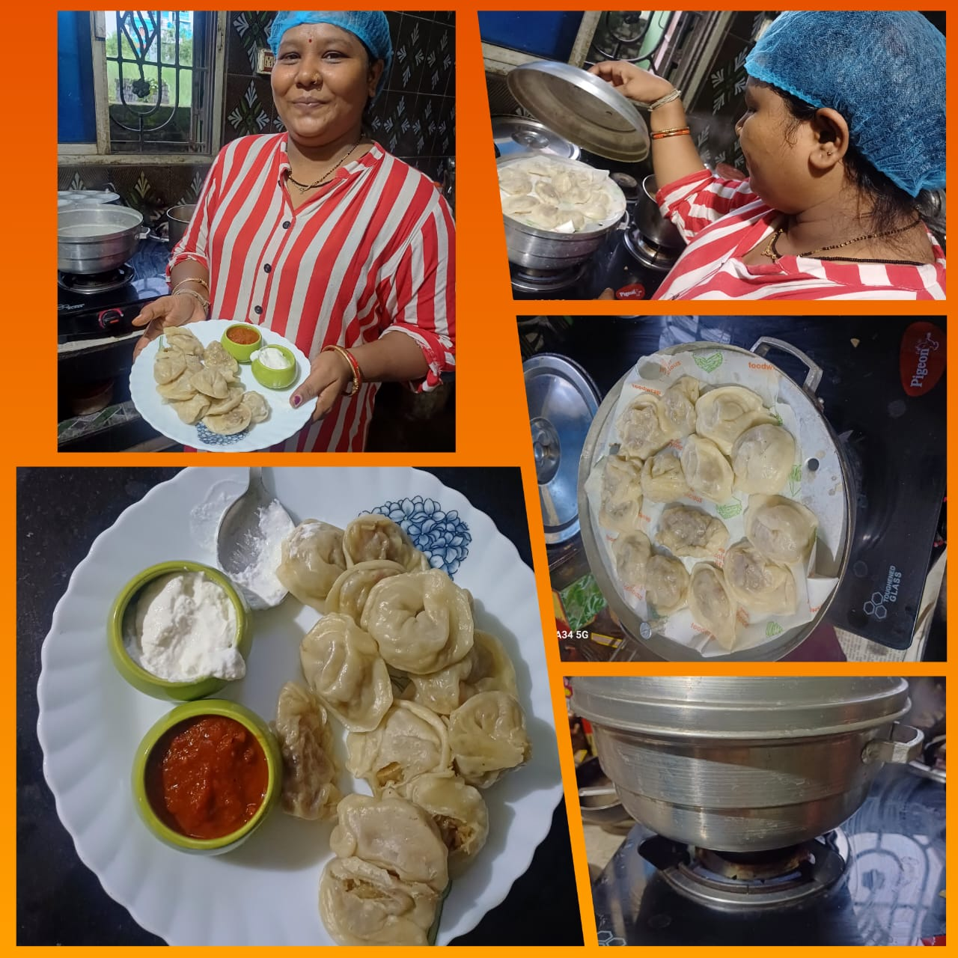

8.Media Highlight

