ANNUAL REPORT 2023-2024
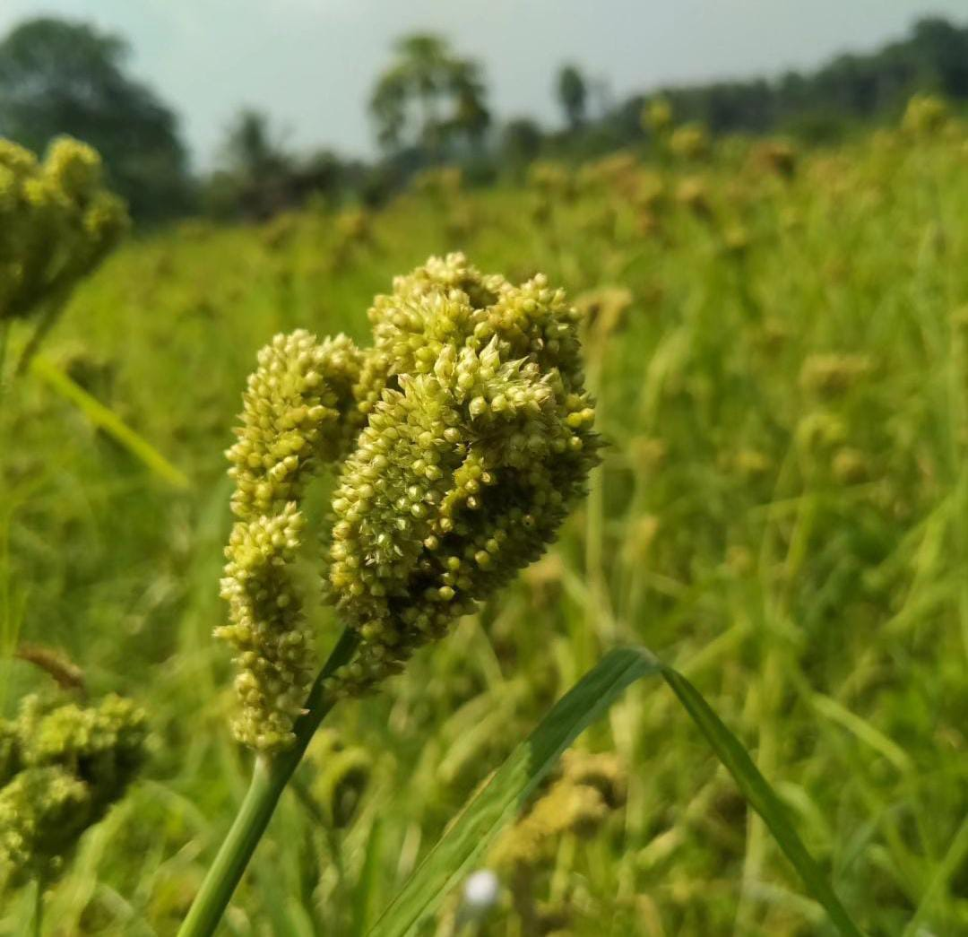 | 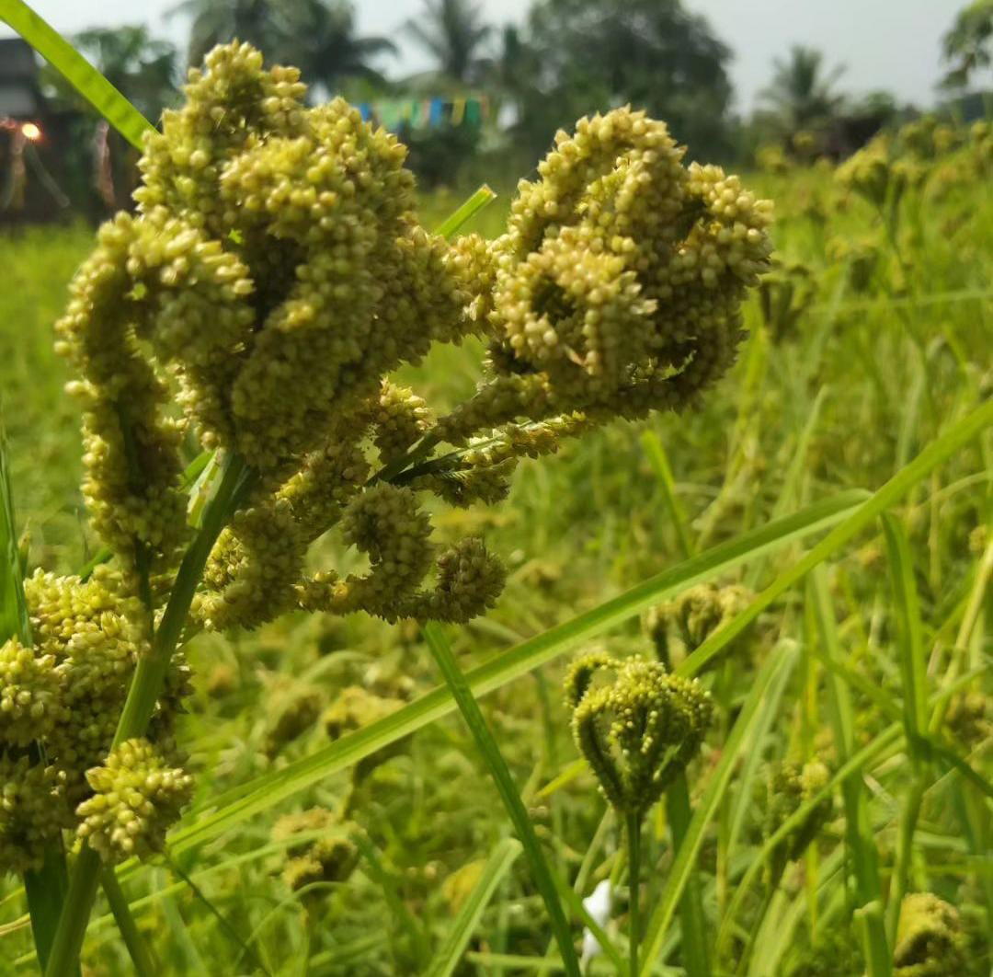
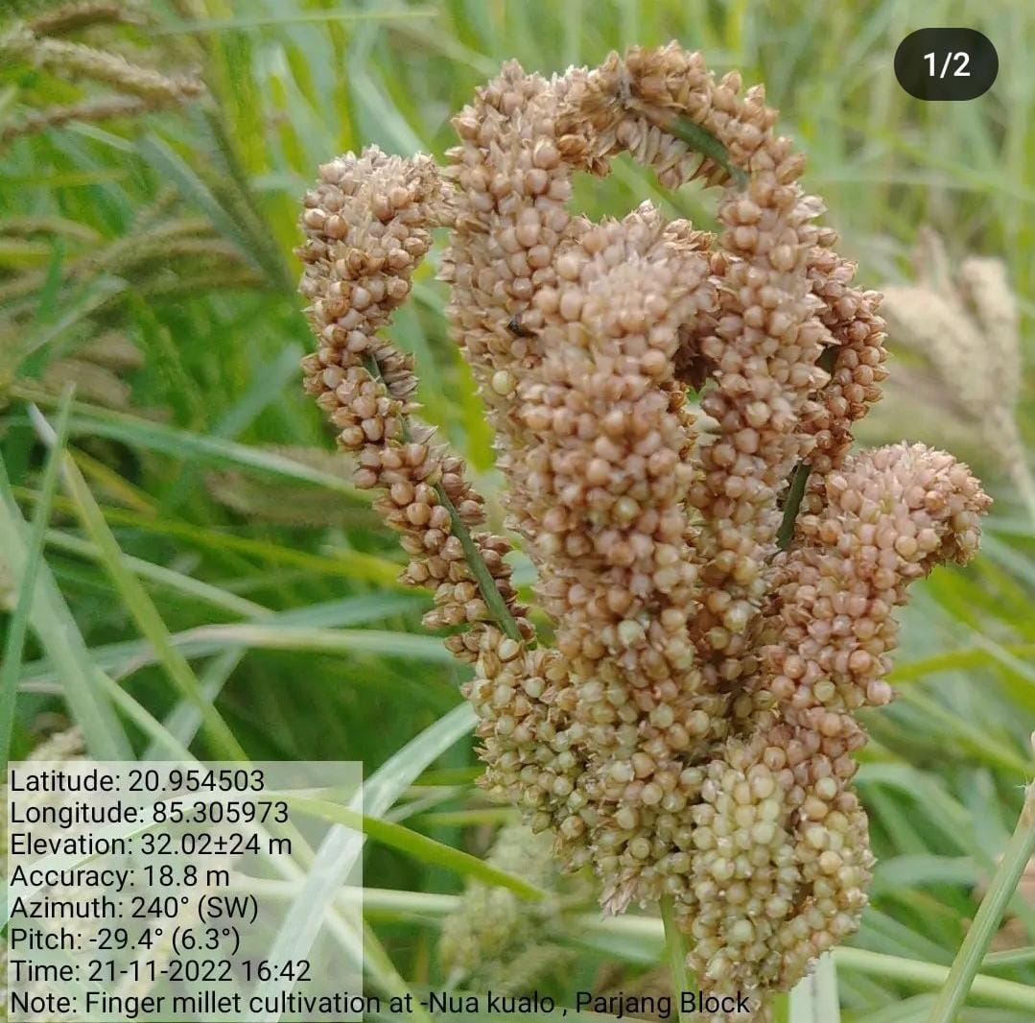 | 

SOCIAL DEVELOPMENT FOUNDATION
Annual Report
2023-2024

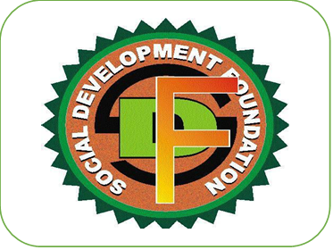

Social Development Foundation
At- Balhar Chhak, Po- Santhapada, Talcher,
Dist: Angul Pin-759104, Odisha
Phone- 9437904108, 8637287963, 7978222373
E-mail: -sdftalcher@gmail.com

Contents
Acronyms
About Social Development Foundation
Message from the Secretary
1} Livelihood Enhancement
A. Farm based Agriculture
1. A Capacity building training programme for WSHG on Jackfruit based food Processing.
1. B Awareness programme on World Jackfruit Day 2023
1. C Awareness programme on Organic Farming
1.D Training programme for WSHG members on jackfruit processing
1.E Panchayat Level Millet Food Mela
1.F Capacity Building Training on Farmer producer Groups
1.G Awareness programme on Millets
1.H Seed Distribution of Millets
1.I Cultivation of Dhanicha
1.J Line Transplanting and Line showing of Millets
1.k Line Transplanting and Line showing of Scented Aromatic rice
1.L Grassroot level training programme for wshg members
1.M Foundation’s Participation in Major workshop cum Seminar.
M.1 Two Days joint Exchange cum Inter learning workshop for NGO’s
M.2 One day Training for NGO workers.
B.2. NON-FARM
B.2.1 Capacity building training programme for WSHG members on EDP
B.2.2 Training programme on Terracotta.
B.2.3 Micro Entrepreneurship development programme for WSHG members on Terracotta Making and Marketing.
B.2.4 Capacity building training programme for WSHG members on Palm leaf en-graving.
B.2.5 BLBC EXPOSURE VISIT.
2.WOMEN EMPOWERMENT
2.1 International Womens DAY -2024
2.2 SHG Group Formation
2.3 Credit Linkages
2.4 Establishment of Micro-Enterprise development Center
3} YOUTH
3.1 YUVA SAMBAD -INDIA@2047
4} WASH
4.1 Global Hand washing Day-2023
5} CSR
5.1 Sensitization workshop on PRI, Line dept, FLWs under CSR
5.2 A C.D initiatives of NTPC/TALCHER, THERMAL (Beautician Training)
6} Success Story
7} Media Highlight
8} Photos
Acronyms
Ac: Acre
APC: Agriculture Production Cluster
ATMA: Agriculture Technology Management Agency
ANM: Auxiliary Nurse Midwives
AWW: Anganwadi Worker
BDO: Block Development Officer
BKRY: Biju Kanya Ratna Yojana
BPL: Below Poverty Line
CBO: Community Based Organizations
CSR: Corporate Social Responsibility
FRA: Forest Right Acts
GOI: Government of India
GOO: Government of Odisha
HIV: Human Immune deficiency Virus
IAY: Indira Awas Yojana
IAS: Indian Administrative Service
IMR: Infant Mortality Rate
KBK: Koraput, Kalahandi and Balangir
KVK: Krishi Vigyan Kendra
MGNREGS: Mahatma Gandhi National Rural Employment Guarantee Scheme
MMR: Maternal Mortality Ratio
NFSM: National Food Security Mission
NGO: Non-Government Organisation
NABARD: National Bank for Agriculture and Rural Development
PDS: Public Distribution System
PHC: Primary Health Centre
PNC: Post Natal Care
PRI: Panchayati Raj Institution
PWD: Public Works Department
QPR: Quarterly Progress Report
RCH: Reproductive Child Health Care
RKVY: Rastriya Krishi Vikas Yojana
RTI: Right to Information
SHG: Self Help Group

A GLIMPSE INTO SOCIAL DEVELOPMENT FOUNDATION
Social Development Foundation, literally meaning “Upliftment of grassroot people” is a non-government Organisation taking all effort for the development of grassroot people & brings about positive changes in the communities in Odisha. Social Development Foundation has been actively involved in development activities since 2010/2011. Along with conservation and resource generation. The Organisation is working towards enhancing the access of people to land, water and forests with increasing the productivity of these resources in environmentally sustainable and socially equitable ways. With this the Organisation is also promoting the conservation of traditional knowledge along with values of marginalized people. Work of Social Development Foundation can be classified in Ensuring Education for all, Maternal & child Health, Promotion and conservation of Agriculture along with climate. Social Development Foundation maintains its head office at-Ballahar Chhak, 3kms from Talcher and 20kms from District HQ. Angul, Odisha, Social Development Foundation has been able to reach the 118537+ Population of 121 Villages of 69 Gram Panchayats of 30 Blocks of 7 Districts.
Vision-To engage, educate and empower vulnerable communities for significant socio-economic transformation.
Mission: Social Development Foundation’s initiatives are focused on Rural Development, Environment, Social Change, Gender Equality, Sustainable Agriculture & Livelihood, Health, Climate Change and in particular to build up an institutional base for addressing the problems of Tribal, Dalit, Rural Poor and women and children at grassroot level. And in furtherance to the above: -

➢ To take up programmes of awareness and consciousness on raising issues about the socio-economic, environmental and political problems of tribal Dalit and rural poor, aiming at reduction of disparity at all levels.

➢ To take up programmes on education for women and children, including legal education.

➢ To Provide necessary assistance and service for the vocational training/ income generation projects for artisans, youth, women, handicapped, socially and economically backward people .

➢ To become self-supporting in areas of agriculture, animal husbandry and processing on no-profit and no loss basis.

➢ To establish a training base for the grass-root functionaries drawn from the target group as well as the young educated professional. The training would cover Health, Environment, Livelihood, Skill improvements and income generating activities.

➢ To promote appropriate technology and renewable and non-conventional sources of energy.

➢ To develop areas of mutual co-operation and understanding among different voluntary organizations, NGO Networks, Research and Resource Organization and other Govt. and Non-Govt. agencies working for similar cause in India or elsewhere.

A note from the Founder cum Secretary

Dear Friends,

It’s my pleasure to inform you that Social Development Foundation has successfully completed Fourteen years of its journey in social development sector. 2023 was an international year of millets for the Global. Much of the focus was on preparing the organisation to meet forthcoming challenges and opportunities.

The organization has been focusing especially for Skill based training, seed conservation, promotion of SRI and SMI for higher yield of paddy & millets, Promotion of food processing, Climate smart agriculture through Jackfruit, Organic Farming for a hazardous free agriculture, Waste Management, Natural Resource Management and its conservation, women empowerment women rights and child rights since its inception. For last fourteen years, foundation has been working in the Angul and nearby district continuously. An energetic team of dedicated young mass engages throughout the year 24x7 for the humanitarian services support, guide and convergence with GOI &GOO.

Our gratitude goes out to all our supporters, partners, organizations, and individuals, as well as our board members, advisers, and entire team. It is our hope that the "Annual Report 2023-2024" will encourage you to continue or join our efforts to support and improve rural society's marginalized sections.

Budhadev Das
FounderDirector
Social Development Foundation

1} Livelihood Enhancement
Farm based Agriculture
- A Capacity building training programme for WSHG on Jackfruit based food Processing.
The foundation conducted a training programme on Jackfruit based food processing at Jamardiha village of Bandabhuin Panchayat of Pallahara Block in collaboration with Panchayat, simultaneously the same was also carried out at K. Nuagoam and Tumdibandha of Kandhamal district and Kankadahad village of Dhenkanal District.
1. B Awareness programme on World Jackfruit Day 2023
Jackfruit Day is annually observed on 4th July. On the occasion of world Jackfruit Day 2023 Social Development Foundation and Maa Grameswari PG observed a day in presence of Ms. Reetarani Karmi, AHO, Pallahara, Abhinas Das JAO PBDA, livelihood experts, PRI members, Mission shakti Staff at PBDA office, Jamardiha Pallahara Block Angul Dist.
1. C Awareness programme on Organic Farming.
A training cum awareness camp was organized by Social Development Foundation Talcher, Angul and local Non-Government Organization(NGO) Farm Foundation At-Permanji, Thuamulrampur Block, Kalahandi district, Odisha. This programme was a part of our campaign “My Vegetable-My Land " project .About 15 farmers, local youth and farm women from villages had joined the programme. The camp was organized to sensitize farmers about the organic and natural farming and their applications in rice and non-rice crops. The farmers were demonstrated the preparation of vermicompost, jeevamruta, ghanajeevamruta, beejamruta, neemastra, bramhastra, agnastra etc.
1.D Training programme for WSHG members on jackfruit processing
On Income Generation Programme, Social Development Foundation, NGO of Balhar Chhak, Talcher had organized a Capacity Building Training on Tender Jackfruit food Processing and preservation for Producer Group members at Jamardiha Village of Bandhabhuin Gram Panchayat of Pallahara Block. Near about 20members participated. Mrs Anita Patra and Gamani Dehury trained the PG members.
1.E Panchayat Level Millet Food Mela
In the past, millets used to be the staple food for tribals in Odisha. As part of its objective to popularize millets in semi-urban and rural areas, the foundation collaborated with the Maa Mangala Producer Group promoted by SDF. the members of the federation managed the millet unit and interacted with local consumers vender and visitors. The women had been trained and were technically supported by NABARD. Packaged and bakery products like biscuits, laddoos, muffins and fresh hot-cooked recipes like salad, sandwiches, vada, biryani and kheer were served to audiences and other attendees. Encouraging response was received, especially by families who were looking for healthier options while not compromising on taste. Through Mandia Café, we didn’t just provide people with healthy and tasty food but also communicated the nutritional benefits of millets. Having experienced millet recipes, people didn’t just eat at the café but also took back biscuits, laddoos and other recipes for their family and friends. The initiative got good media coverage
1.F Capacity Building Training on Farmer producer Groups
In order to meet the increasing demand of Vegetables Fruits Maize and Jackfruit for growing population, the enhancement in production and productivity is felt to the key factor which can substantially be addressed through organization of trainings and capacity building of the stake holders.
OBJECTIVE: -
1. To impart scientific knowledge of better management practices to enhance productivity.
. 2. To increase levels of knowledge, skill and expertise amongst the rural masses, women farmers and members of WSHGs.
3. To generate self -employment and income enhancement in rural households through Climate smart agriculture.
4. To make the State self -sufficient in vegetables, fruits, maize production.
1.G Awareness programme on Millet and Hybrid cum Indigenous Maize
Social Development Foundation Talcher organized a “Awareness Programme on Millets on 31st May, 2023. The main mandate of this training is to raise awareness about the modern aspects of improving millet productivity through scientific cultivation technology and the importance of millets in human diet and rural economy. A total of 25 nos. of farmers including locals participated in the training. The participants were briefed about the status, importance and challenges of Millets in India by Jadav Sahu VAW of Sakosinga, Banarpal Block.
1.H Seed Distribution of Millets
Social Development Foundation has organized a massive program to raise awareness about Millet production and its nutritional value among farmers and the general public of Banarpal, Talcher and Perjang block of Angul & Dhenkanal District. Under the initiative, millets farmers in the district are being identified and trained, provided with technical assistance and seeds. In the current Kharif season steps are being taken to cultivate millets on at least 5 to10 hectares of land in each of the 4 target blocks of the both districts. In association with the department of Agriculture (Banarpal Block) foundation organized a distribution of millet seeds the foundation distributed millet seeds among farmers in presence of Mr. Badal Ku. Dash VAW of Bada Kerjang, Jadav Sahu VAW of Jamunali, PRI Members of Concerned Panchayat and staff of SDF. VL-MANDUVA -376 mini kit to the farmers at -Jamuda jungle, Balaramprasad Jamunali village of Banarpal Block Angul District.
1.I Cultivation of Dhanicha.
Social Development Foundation, Talcher and Department of Agriculture and Farmers Empowerment (Block Agriculture Department, Talcher). This program was reviewed by Mr. Pravat Kumar Baidya, Agriculturist.
*Advantages of dhanicha as a green manure: *
1. It is a generally used as green manure crop. It can be grown on all season having sufficient moisture in soil. It not only improves physical properties but also helps in meeting nitrogen requirement of succeeding crop.
2. The green manure is not only to incorporate the nitrogen but also to improve the soil health by improving the physical and chemical properties of the soil.
3. It also helps to maintain the organic matter of the soil.
4. Green manuring improves the aeration in rice soil by stimulating the activities of the surface layer of algae and bacteria.
5. Green manure crop absorb nutrient from the deeper soil layer and leave them on the soil surface layer when incorporated for use of rice
6. Depending upon the humus formed green manuring increases the water holding capacity of light soils.
Sesbania spp. commonly known as Dhanicha seeds are available free of cost in the Department of Agriculture. Only those who have farmer card or farmer id can take advantage of this. It is available in all blocks of the state for the farmers under the project "Promotion of improved Package of Practice" of the Department of Agriculture. Farmers will get incentive of 500 rupees if they cultivate 10 kg of dhanicha per acre.
1.J Line Transplanting and Line showing of Millets
Line transplanting of Millet (Ragi) is being promoted by Social Development Foundation (SDF) as seen in these images from the Jamunali, Field area of Banarpal Block, Angul dist.
17 acer of single patch ragi seed bed prepared at-Jamuda Jungle, Dharmpur &Jamunali with the presence of VAW, FLWs PRIs, CRP and staff of SDF.
1.k Line Transplanting and Line showing of Scented Aromatic rice
With the help of Progressive farmers of Padasahi & Nediguda, the foundation had implemented Line transplanting and line showing of Scented paddy, and Traditional seeds Chinamali etc. They were provided with organic fertilizer, organic manure and seed treatment and were made aware on Integrated pest management in convergence with Agril. Department. More about 10Acres of cultivated land.
1.L Grassroot level training programme for wshg members.
Organised a three days Grassroots Level Training Programme (GRLTP) for mature SHGs member with support of NABARD at-Jhimiripalli, Balaramprasad and kampala village Pallahara, Banarpal and Athamallik Block of Angul Dist. 55 WSHG members were presented in the said programme. Mr. Benudhar Pradhan inaugurated the programme. Mr. Dharmendra Mohanta (Managing Director, Pallahara FPO), Bikram Bisi (CEO, Pallahara FPO), Jharna Guru (Ward member) were present in the programme. Manoranjan Swain (Ex-Resource Person of NAFCC, Nuapada Pilot Project, NABARD enlightened about the 10 commandments of SHG.
1.M Foundation’s Participation in Major workshop cum Seminar.
M.1 Two Days joint Exchange cum Inter learning workshop for NGO’s.
A two Days joint Exchange cum Inter learning workshop for NGO’s was organised by Agragamee, Kashipur Rayagada at-Hotel Presidency, Bhubaneswar. At the outset Mr., Achyut Das welcomed to all the dignitaries and participants from different districts and enlightened the participants. Participants from West Bengal, Jharkhand, Chhatisgarh, Andhra Pradesh and Odisha were present in the programme. The participants shared their journey and success stories in their respective fields, they also learnt about the entrepreneur aspect from Mr. Soumendra Roy, BMZ-KKS Germany.
M.2 One day Training for NGO workers.
Social Development Foundation, Talcher Coordinated an event of NABARD for NGOs on one day Training Session of Field Level Workers. Sri Asutosh Ray, DDM NABARD of Angul was present on this occasion and gave many useful tips and information on how to work as an NGO in field and also how an NGO can get associated with NABARD to work in different sectors of NABARD. Mrs. Pratibha Sethi KVK also shared many information and programs of KVK where any NGO can work and do good to the Society. Representatives of NGOs like fees, spandan, viswa yuva kendra, back to village Charmallik FPO, Social Development foundation and Mr. Ashutosh Mishra AGM Jindal CSR etc. were present in this event. Total 5 NGOs, 1 CSR and 1 FPO participated in this event. This event took place on 6th March 2024, at KVK Angul Conference Hall.
M.3 Basic program on Financing Agri Start-up
Attended 3- days Basic program on Financing Agri Start-up along with members from Bankers, OFPOs, NGOs and CSO's from Jharkhand, West Bengal, Odisha etc organized by ICAR CIFA and BIRD-NABARD Kolkata at -CIFA Camus, Bhubaneswar, Participants were exposed to knowledge like Rural incubation center (ABIC/RBIC), Valuation of Agri -enterprises, scope of start-ups in India, Venture capital and seed fund, preparation of DPR, scope for raising funds, and field visit. Govt officials also participated and facilitated the process of training programme. A total of 30 participants participated in the 3days qualitative training and enlightened about the "Agri Start-up" programme. All the concerned initiatives have made them as successful trainer/motivator with encouraging the participants in the vicinity.
M.4 capacity Building training programme on Horticulture Scheme
A one-day capacity Building training programme on Horticulture Scheme was organized by Department of horticulture, Kishorenagar block of Angul District. On behalf of Social Development Foundation, I as resource person presented on Jackfruit value addition (Raw and Ripe), cultivation, branding, marketing and packaging etc. in presence of line department, FLW, entrepreneurs, SHG & JLG members and CBOs. Angul Zilla Parishad Chairman Mrs. Babita Pradhan inaugurated the meeting and she assured full support for jackfruit mission, NRM, Animal Husbandry, Fishery, APC, WSHGS in the block. Chairman Kishorenagar Block, Chairman ATMA, 12 &13 number zone of Zilla Parishad & Representative of Athamallik MLA etc were present in this occasion.
1.N Video documentation on Millets based Food Processing
The economic slowdown has hit hard several big companies due to lockdown and shutdown. However, with good push from NABARD and Social Development Foundation (a grassroot based NGO) rural women who never stepped out of their house without any support, are now earning a decent living and lot of respect from millets-based food processing. Here we are discussing about rural women entrepreneurs from Dharampur village of Talcher, Angul Odisha are creating their own story of success. To add on in this context, News18 Odia & Etc Bharat, Angul regional electronic media channel showcased their efforts on Millet based food Processing activities.
B.2. NONFARM
B.2.1 Capacity building training programme for WSHG members on EDP
B.2.2 Training programme on Terracotta.

In an effort to reclaim the dying terracotta work, an age-old artisanship of Angul district, social Development Foundation, has come out to train the community members which will not only help them for new livelihood opportunities but also give back their socio-cultural identity. It also provides technical knowledge cum guidance and market linkage support to the craftsmen and helps them find a better price of their products in the market. An only day sensitisation training programme has been organised at -Tukuda village under Chhendipada Block of the district. The initiative will benefit more than 30 families of Kumbhar community who are known for the traditional craftsmanship since ages. DDM, NABARD, Mr. Ashutosh Roy were present in the training programme. While addressing the occasion, Ashutosh Roy said, “The programme was initiated to bridge the skill deficits and to facilitate optimisation of production activities among women SHG members and producer group”.
B.2.3 Micro Entrepreneurship development programme for WSHG members on Terracotta Making and Marketing.
The MEDP Terracotta Training Programme for SHG Members was held at Tukuda Village of Tukuda GP training Hall at 10:00 A.M under the chairmanship of Chief Guest Mr. Prasant Kumar Sahu Sarpanch Tukuda enlightened the participants. Officials from Chhendipada block, BDO, EO, PAC member actively participated and shared information on livelihood activities on Terracotta to wshg members, concern block Co-Ordinator from OLM and Mission shakti also participated and shared “Why Self-Help Group is important” in present context. Mr. Ashutosh Roy, DDM NABARD Angul also joined the training programme and encouraged the WSHG members and shared his ideas and experiences. PRI representatives and Media were present in the said programme. The event was marked with lighting of lamp by Chief Guest & other guest of honour in the dais. At the outset Mr. Budhadev Das, Secretary, Social Development Foundation welcomed all the members of SHG of concern Village, Media & guests in the programme. Mr. Bijay Kumar Behera was selected as trainer and trained the members in the said training.
2. Marketing Interventions: - On this occasion, Mrs Mamatarani Bisimajhi, Proprietor of “MAMATA UDYOG”, Talcher had joined the MEDP programme and enlightened the process of marketing and branding of Terracotta products.
3.Financial inclusion
Mr. Amulya Ku Sahu (BM, IOB, Jarapada Branch, Angul), Mrs Gitanjali Sahu (Bank Mitra, IOB Jara pada Branch) explained about the Micro-credit, Bank Linkages, Use of ATM & different schemes of Central Govt. i.e. Sukanya Samrudhi Yojana, Atal Pension Yojana, Pradhan Mantri Suraksha Yojana & Pradhan Mantri Jeevan Jyoti Bima Yojana, Digital Banking, Vishwakarma Yojna, Digital Literacy, Mudra loan and other loan schemes.
4.Entrepreneurship Development – On behalf of GM-DIC, IPO, Chhendipada and DRP visited the venue and shared information on the PM-FME & MSME scheme, Credit Linkage, Atma Nirbhar Bharat Yojana and One Dist One Product (Mango) etc.
5.Exposure Visit – In accordance with the provisions to boost the confidence of trainees to adopt the activity and venture into setting up of micro-enterprise, one-day Exposure visit was organized to Kuibahal village, Binka Block, Sonepur district on 13 February 2024 for better and deeper understanding of Terracotta industry - the entire process of operation including marketing, branding and packaging.
The following topics were discussed: –
• Promotion & Strengthening of Terracotta based products and producers.
• How to develop Tukuda as an ideal Terracotta Production unit in future through mechanized large-scale
production & market linkage.
B.2.4 Capacity building training programme for WSHG members on Palm leaf en-graving.
Talapatra Khodai from Odisha, as an art form, has shown the world that art is in no way limited. Social Development Foundation NGO Talcher Angul District of odisha is being conducted an awareness programme on Capacity Building training on Talapatra engraving at Bangu village of Bantol Panchayat। As many as 25 WSHG members were participated in the said programme

2.WOMEN EMPOWERMENT
2.1 International Womens DAY -2024.
On 7th March 2024, Social Development Foundation, Talcher and ICDS/Talcher, Angul jointly organized a Workshop on International Women’s Day 2024. A total of 65 women from different academics, block offices, AWW, ASHA etc of talcher block of angul district were attended the workshop.
On 11th March 2024, Social Development Foundation, Talcher and NABARD had jointly observation of International Women’s Day 2024 at AUCCB Conference Hall of Angul. A total of 65 women from different blocks of angul district were attended the noble programme. Mrs Shukla Chakrabortty Principal of DAV Dera, Talcher & Excise SP Madhusmita Nayak was the Chief Guest of the function. Mrs Chakrabortty briefly enlightened the WSHG members on “INVEST IN WOMEN ACCELERATE PROGRESS”. Mrs. Madhusmita Nayak encouraged women to participate in the social and economic development of the society and help to bring equality. She also spoke about the dangers of social media and how easily women can fall prey to the cyber frauds and criminals. Mrs. Sanjukta Bebartta (Lect.in Education Talcher Autonomous college) in his address elaborated various programs undertaken by the institute for the empowerment of women. Ms. Kabita Pradhan BM UNION BANK Kumand branch and Mr. Santosh Pradhan President of AUCCB, angul (Guest of Honour) addressed the gathering and spoke about the need of women to be economically independent and inspired to take the lead. Mr. Ashutosh Roy DDM NABARD and Special guest talked about the status, role and importance of women in building a safe society through digital technologies. Earlier, Mrs. Mamatrani bisimajhi programme officer of SDF welcomed all the guests and appraised about the activities of the women cell of the institute. Chief Guest and Guests of Honour distributed Mango sapling and memento to the change agents of various activities of NABARD in d in connection with the IWD 2024. Mr. Budhadev Das, Secretary of SDF proposed the vote of thanks.
2.2 SHG Group Formation
Capacity Building Training programme for WSHG was organized by Social Development Foundation, Talcher at Balinali, Chhendipada Block of Angul Dist. Resource person from OLM participated in the event. 30 WSHG members were also present in the said meeting.
2.3 Credit Linkages
Bank linkages are planned and done on a large scale for a prescribed amount, as decided by the bankers, without taking into cognizance the needs of the women and their capacity to repay. The process of mutual help, joint development, acceptance and internalization of SHG rules and norms are now, largely, missing. Yes, credit is certainly a lifeline for rural women. However, managing credits in groups, under the present terms and conditions, requires a different orientation altogether.
2.4 Establishment of Micro-Enterprise development Center (Mamata Udyog)
Effective partnership will be established with key business players to market the products of the producer associated in the project. Our sister organization “Mamata Udyog “as a marketing agency promoted by Social Development Foundation one of the Business partner and marketing agency to take marketing responsibility of the product. The cluster level producer organization will be promoting business organization to sold the product in different market, exhibition, online business, home delivery & promote marketing in vending zone of township of the district & state. So here NGO acting as backward and forward linkage with WSHG.
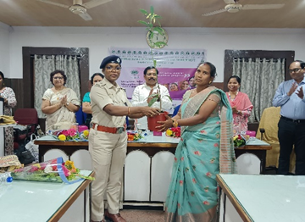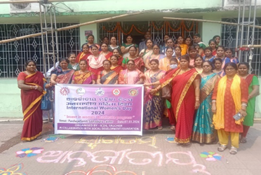
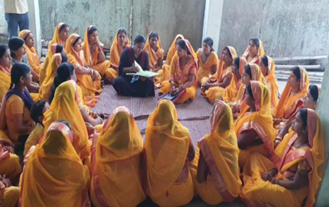
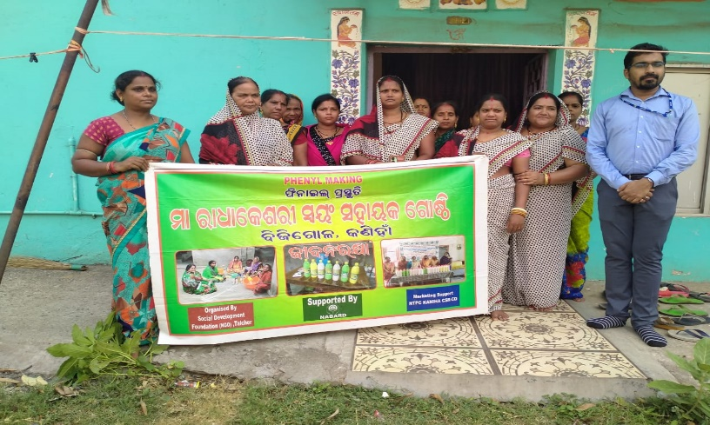
3} YOUTH
3.1 YUVA SAMBAD -INDIA@2047
Central Ministry of Youth Affairs organises an interaction session titled ‘Yuva Samvad: India @2047’ at selected Universities/Colleges during the year 2023-24. The Yuva Samvad in a single phrase can be defined as– “for the youth, by the youth, of the youth”. The Samvad will be an unstructured discussion among youth led by persons of eminence.

The dialogue and discussion during the Yuva Samvad India @ 2047 will be based on the theme of Panch Prans (five resolves) as proclaimed by Prime Minister, Narendra Modi, during the Independence Day Speech on August 15, 2022.

The Panch Prans are: –
- Goal of Developed India
- National Unity and Solidarity
- Remove Trace of Colonial Mindset
- Sense of Duty among citizens
- Take pride in our heritage and legacy.

Yuva Samvad initiatives aim to rekindle the spirit of patriotism and values of India’s Freedom Struggle by engaging the youth in various events. This will help showcase ‘Youth Power’ and reinforce the five resolves ‘Panch Pran’, among the youth of the country.

The Social Development Foundation is selected by the Central Ministry of Youth Affairs to organised Yuva Samvad, during the month of January and is one among the 3CBO’swhich got selection to conduct this programme, under NYKS angul).

The Yuva Samvad programme was conducted on 04th August 2023, from 9.30am to 1pm, at Godtal Regional H.S School. 250 students and volunteers participated in the event. The idea of India @ 2047 and Pancha Pran of Amrat Kal were explained and discussion on these concepts were conducted.
Samvad Session I – was conducted from 9.30am to 10.30am. This session was led by Dr Narendra Paikray (Principal of Godtal Regional H.S School). A seminar and open discussion were held on the topic of Role of Youth in Indian Democracy.
Inaugural session - The inaugural session commenced at 9.00am. This session started the NSS anthem. The welcome speech was given by the Secretary SDF Mr. Budhadev Das. The presidential address was delivered Mrs.Mamatarani Bisimajhi Programme officer of SDF Then lamp lighting ceremony was done by the Chief guest of the day, Sri. Brajakishor Pradhan (MLA, Talcher) This was followed by his inaugural speech and he talked about the Panch Pran/ Five Resolves. He mentioned about the necessity of unity and integrity and the citizen’s duty and responsibility in nation building. He further talked about how youth need to be more knowledgeable about the Panch Pran/Five Resolves in order to shape them into great leaders and good citizens and to make them more known about various social economic problems of this country so that we can build a better India. Then Mr. Susant Tripathy National Awardee was called for the felicitation speech. After that NSS Programme Officer Mr. Pradeep Dogra delivered vote of thanks. The inaugural programme ended at 11:40am, with the National Anthem.
Samvad Session II - was conducted from 11.30am to 1pm. This session was led by Mr. Satyanarayan Parida. He is a leadership consultant, motivational speaker, certified trainer and winner of many prestigious awards and accolades like Asia Book of Records, India Book of Records, MHRD etc. The interactive session was organized on the theme of Crafting Tomorrow’s leaders. The session included a lot of interactive activities and games of which each of them gave a moral at the end which included to never under estimate yourself, a lesson that a lot of opportunities are present in life but they will never come after us, thus we have to go and find them ourselves and how we have stay vigilant of our surroundings and our studies and overall day to day life. These were taught through different activities and games.
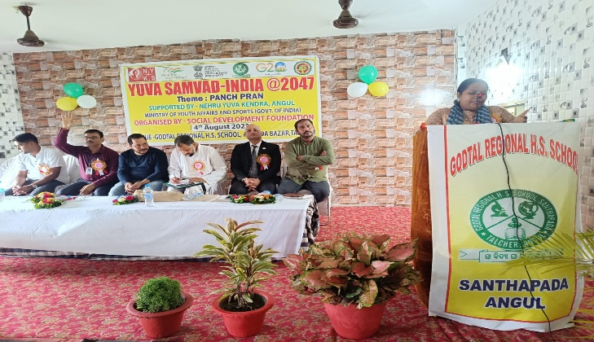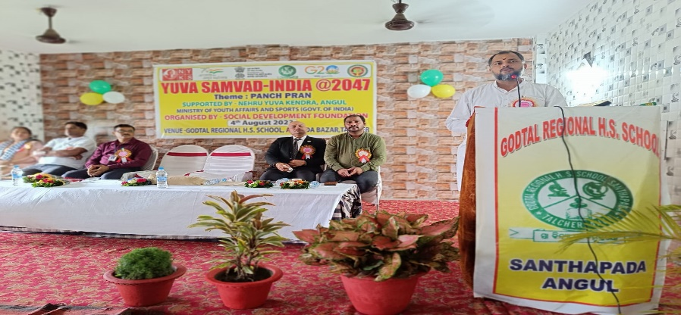
4} WASH
4.1 Global Hand washing Day-2024
Global Hand washing Day is an annual global advocacy day dedicated to increase awareness and understanding about the importance of hand washing with soap as an easy, effective, and affordable way to prevent diseases and save lives. Every year, 1.7 million children do not live to celebrate their fifth birthday because of diarrhea and pneumonia.
Hand washing with soap is among the most effective and inexpensive ways to prevent these diseases. This simple behavior can save lives, cutting diarrhea by almost one-half and acute respiratory infections by nearly one-quarter. Hand washing with soap impacts not just health and nutrition, but also education, economics, and equity. It is well known that 10% of common diseases that has impact upon child health are due to dirty and unwashed hand. Unsafe Hand are responsible for intensifying diarrheal and stomach infection. Basically, it was originally created for children and school. It is a campaign to motivate and mobilize millions around world to wash their hands with soap.
In this connection the foundation had organised a workshop on World Hand wash Day at- St. Xavier School, Kashipur, semelpadar primary school, Kalahandi and on 15th October 2023/24. The meeting was attended by representatives from block medical officer, Asha, AWW and PRI members from operational villages. A total 100 participants including 75 students also participated in the workshop. Mrs. Mamatarani Bisimajhi, Programme Officer and Binay Ku. Sahu of Social development foundation facilitated the workshop.
Objectives of the Workshop: -
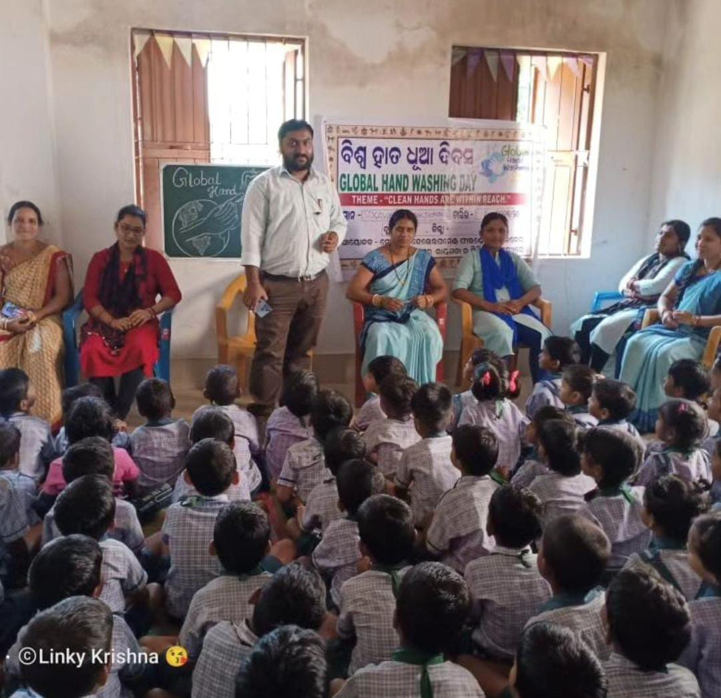
• How to wash your Hands
• Clean your hands with warm water
• Apply generous amount of Soap
• Rub your Hands together for 20Seconds
• Dry your Hands with Towel.

5}CSR
5.1 Sensitization workshop on PRI, Line dept, FLWs under CSR
Preparatory meeting on Millet based food processing at-Bantol G.P, Talcher Block। In this occasion Smt, Jayantilata Pradhan Sarpanch Bantol, EO, PRI members, MBK, CRP - Mission Shakti, OLM staff, President of WSHG groups and staffs of SDF NGO were presented.
5.2 A C.D initiatives of NTPC/TALCHER, THERMAL (Beautician Training)
Beauty culture is not a work but it has much deeper significance. An attractive appearance has become pre-requisite to move forward in life. Training in Beauty Culture & Hair Dressing helps not only in personal grooming but is Career Oriented also. The theoretical and Practical Training in beauty culture imparted to the girls helps them in establishing themselves. Women are now becoming more beauty, health and fashion-conscious day by day and pay more attention to body build up as well as hair style concern as part of their personality development. To fulfil the above demand, NTPC –TALCHER THERMAL and Social Development Foundation (NGO)Talcher have organized a 15days training programme from 21/11/2023 to 05/12/2023 in which 20 girls and WSHG members from peripheral villages of Jagannathpur, Santhapada, Bantol and gurujanguli panchayats are participants and are being trained on Beautician. The program was inaugurated by Mrs.Bipasa Deb President of Sagarika ladies club in presence of other dignitaries such as Mrs. Sarmistha Madam General secretary Sagarika ladies club, Mr. Sahadev Sahoo Santhapada Sarpanch, Mr. Shakeel Ahmed DGM-HR, R/R CSR NTPC- TTPS, Mr. Budhadev Das Founder cum Secretary Social Development Foundation. Post inauguration a demonstration on the skill was done by Ms. Sunita Barik professional trainer. At the Outset Mrs. Nibedita Madam HR/CSR welcomed all the participants and dignitaries.
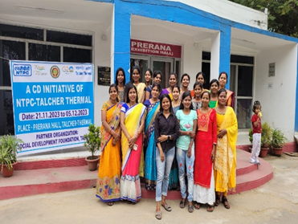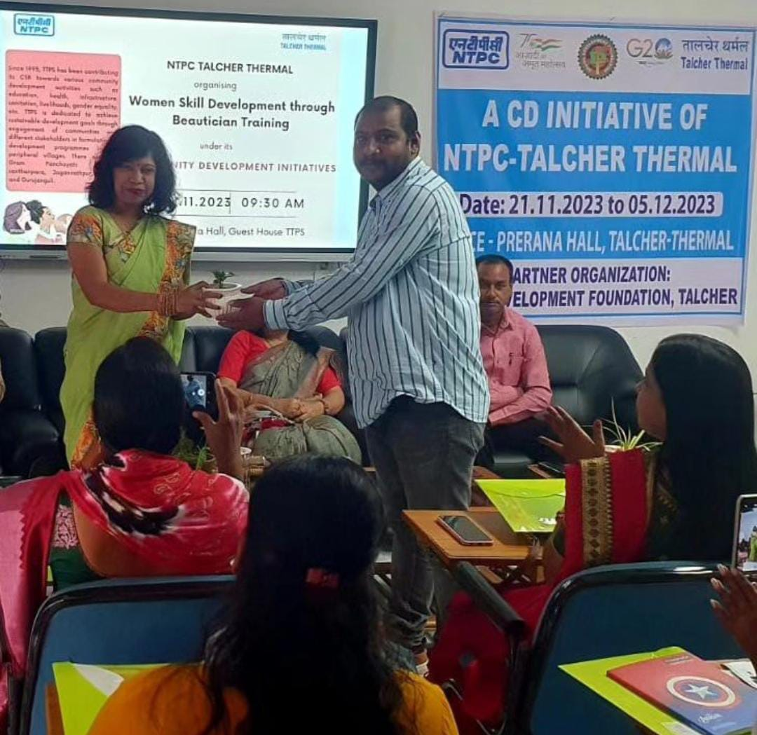
6} Success Story:-
A success story of micro-entrepreneur from struggle to success
Being a good mother and home maker is the goal of every housewife, but this is not only the motto rather she balances work and family by setting up an example for destituted, poor, neglected tribal women and teaches them to live with pride and equality. She not only trained herself also gave training to others on behalf of foundation. With the help of Punjab National Bank, Talcher Thermal and Social Development foundation she opened a rural mart in the name of Mamata Udyog at Ballahar Chhak, Talcher and even employed 3 ladies. This mart has organic rice, manually pounded rice, pulses collected directly from farmers cold press oil, wild honey, tamarind, hill broom, oilseed crops, Millets (such as Finger Millet, Great Millet, Foxtail Millet, Ditch Millet, Pearl Millet, Barnyard Millet & Proso Millet). Various ready-made food items from millet and jackfruit such as Mixture, Cake, Rose Cake, Noodles, pasta, Arisha Pitha, Pickles, Papad, Chips etc. are available at affordable prices. Udyog also focuses on selling terracotta items, bamboo Crafts, jhute bags, palm leaf carvings collected from small and renowned farmers and skilled artisans. To enhance the productivity & increase the participation of women in business she installed 2 processing unit where varieties of flour and spices are processed at Banarpal and Chhendipada blocks and has employed 5 ladies. Besides this she also provides catering services to government and private institutes and corporate bodies. Students from National Institute of Technology Rourkela, SOA University Bhubaneswar and Gandhi Institute of Technology, Gunupur also visits her rural mart for their further learning on marketing, branding, packaging and business strategies etc. She made sure to provide income round the year to the WSHGs by providing a platform at her store. With the help of NABARD and in coordination with the local corporates NTPC, MCL she provide trainings on food processing to women of the SHGs in the districts and various rural areas of the KBK district. As for her this is just the beginning, there’s more to achieve. We wish her best for her venture.

Mrs.Mamatarani Bisimajhi
Mamata Udyog
Talcher

7} Media Highlights
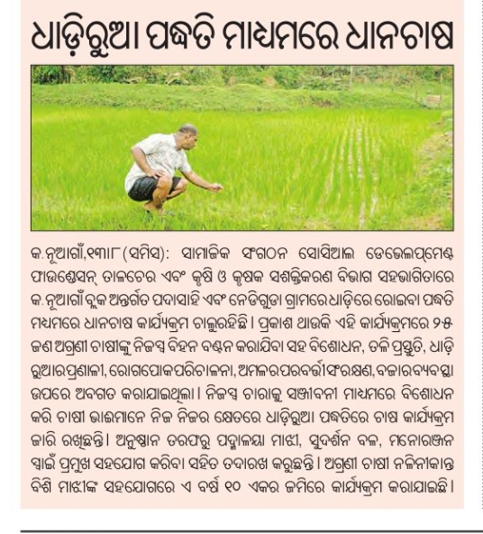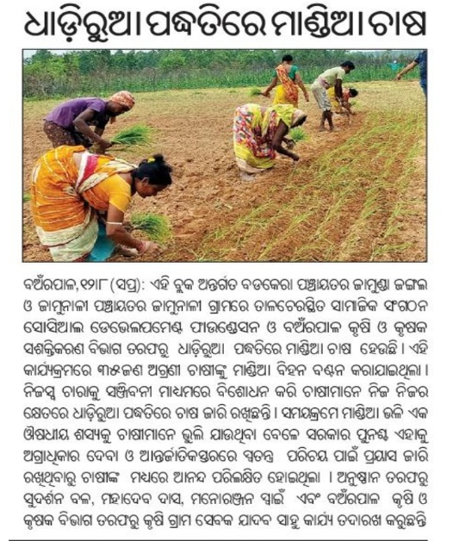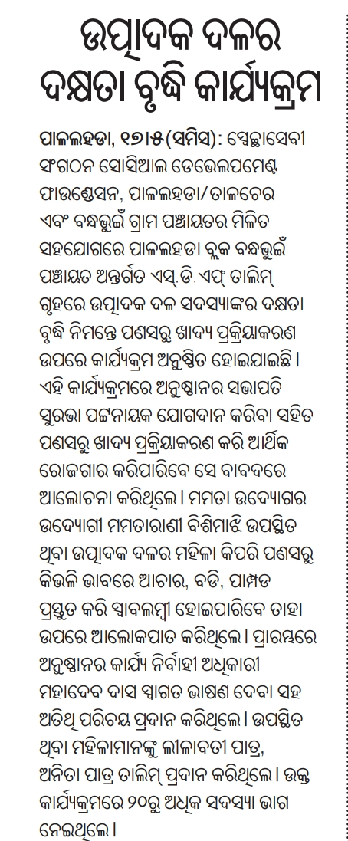
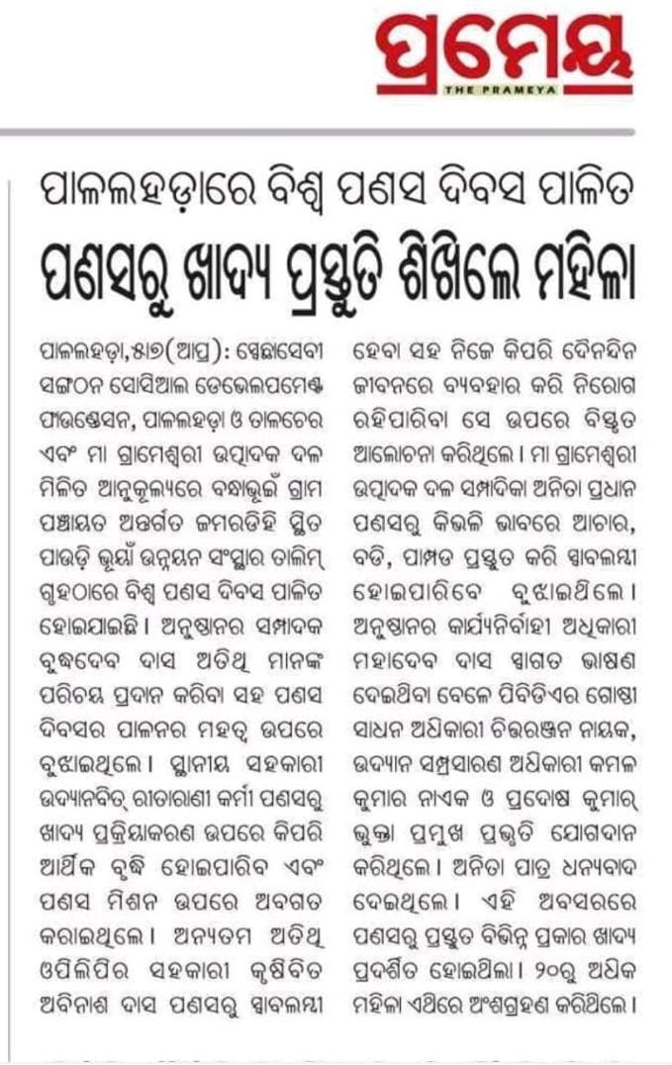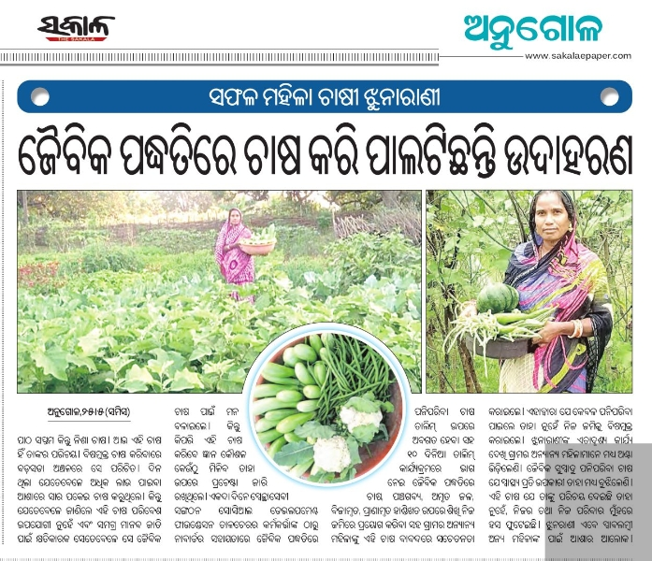
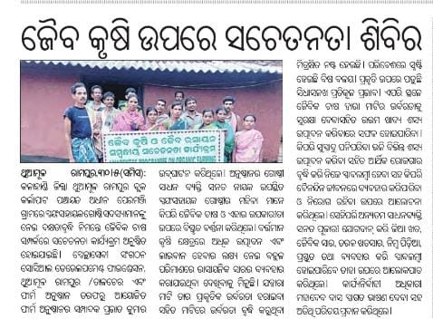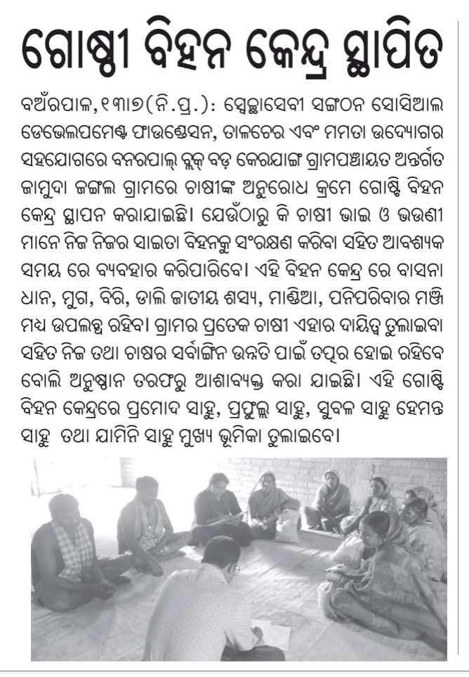
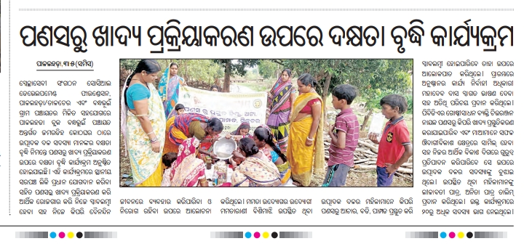
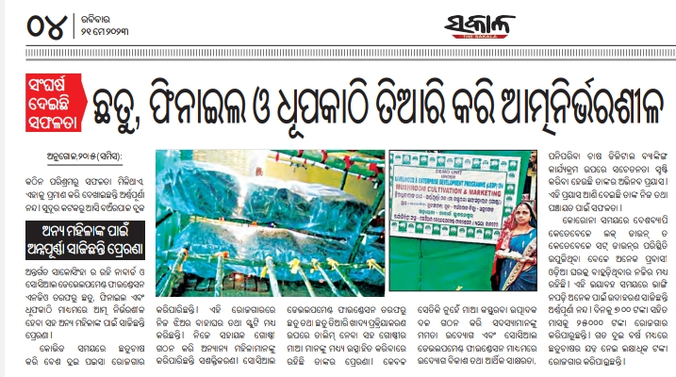
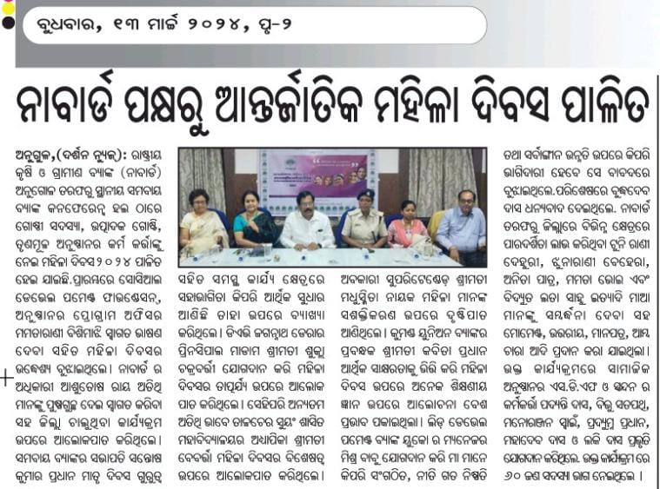
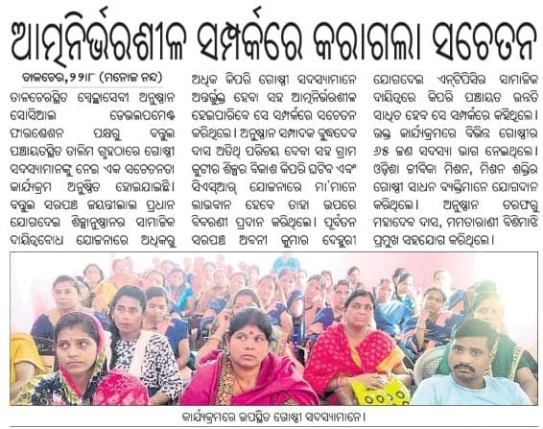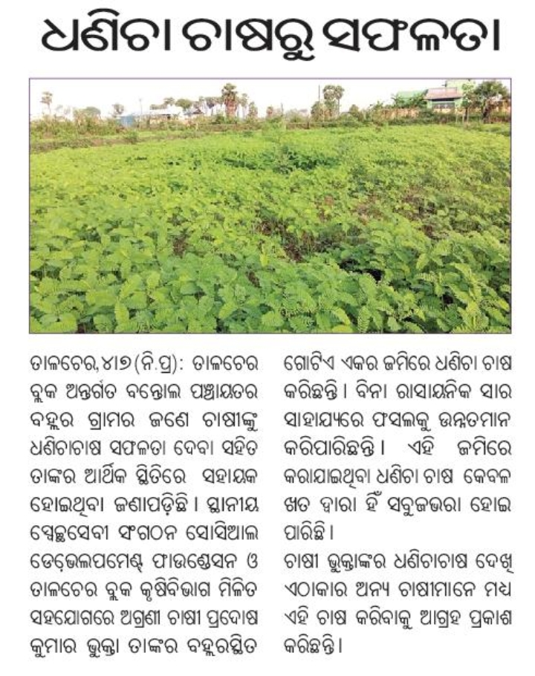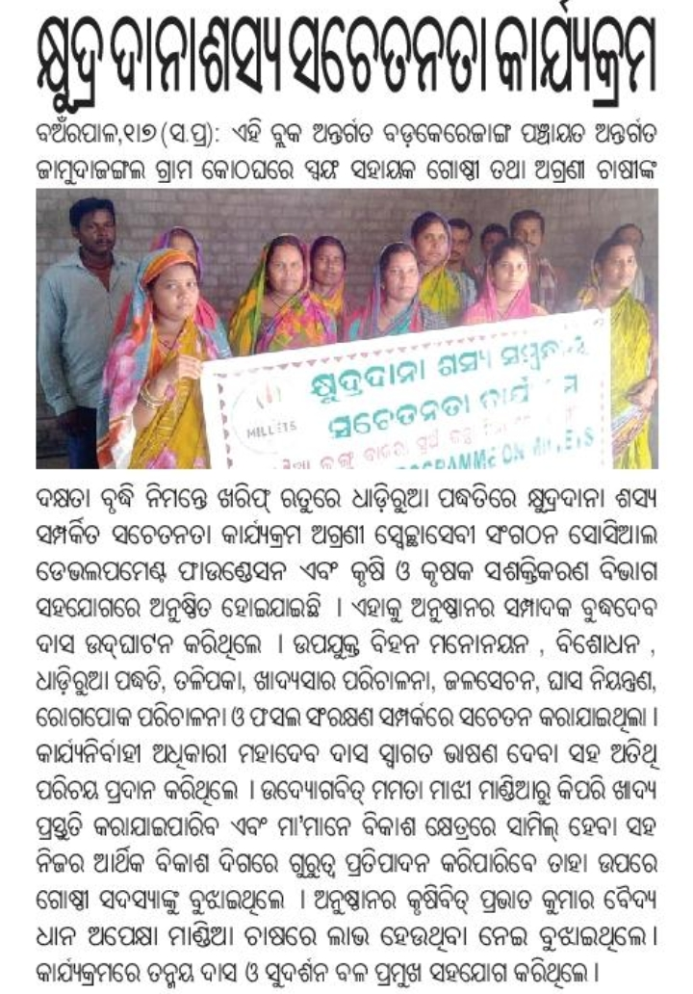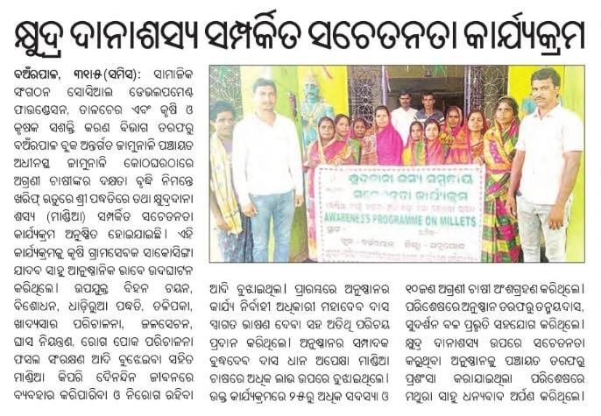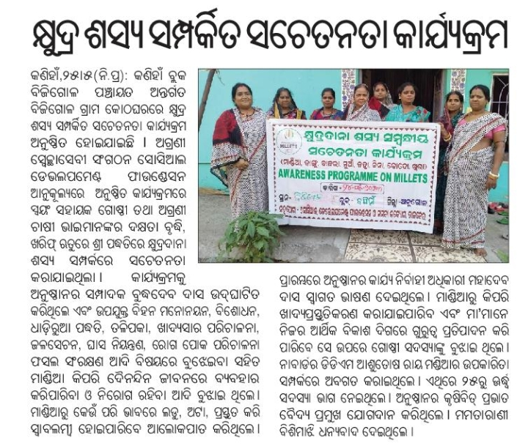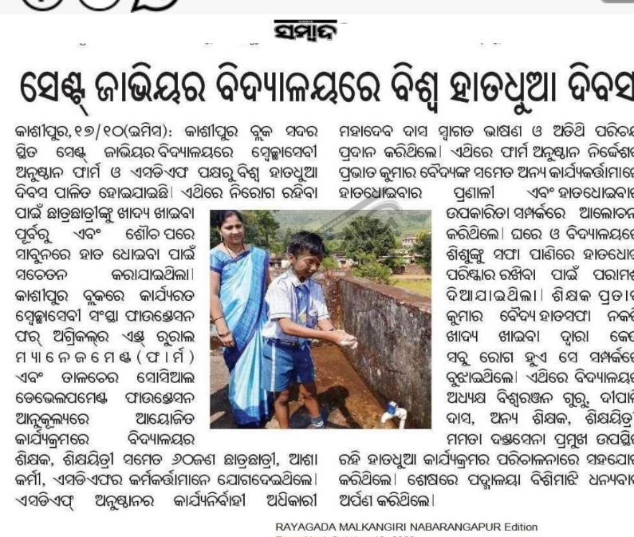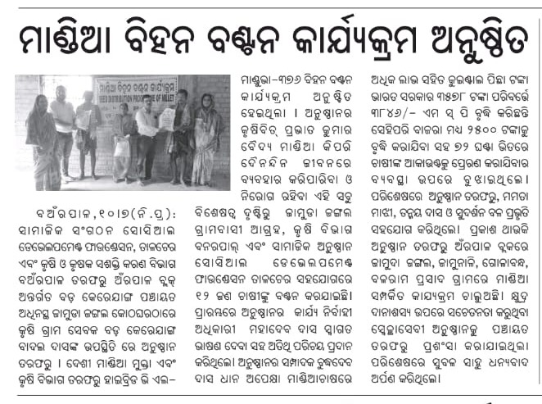8} Photos
